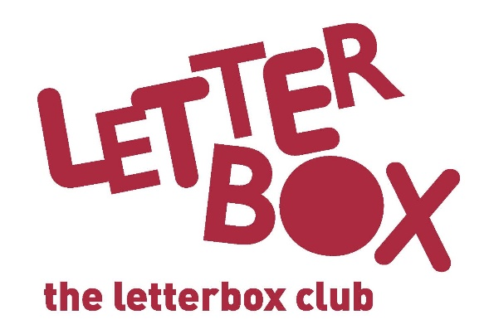

Top Letterbox Tips - Parcel 1

The Letterbox Club provides six, monthly parcels of books, games and stationery to children and young people across the UK. It’s run by a reading charity called BookTrust. For more information please visit www.booktrust.org.uk/letterbox-club-families

Here are some ideas for supporting your child with this month’s parcel:
- If your child enjoys Dog Man you could help them create their own comic strip, either an extra chapter or one with their own characters.

- Encourage your child to carry a book with them to read during journeys to help them get into the habit of reading.

- Your child can use the pencil in this month’s parcel to complete the drawings in Dare you to Doodle.

- Why not play the £100 game with your child? This is a fun money game that you could play together – it’s quick to play. You can change the game if you want by making up new rules.

We hope you both enjoy being part of the Letterbox Club!
The Letterbox Club Team
Did you know? Young people who read for pleasure make significantly more progress in vocabulary, spelling and maths than young people who read very little (Sullivan and Brown, 2013).

