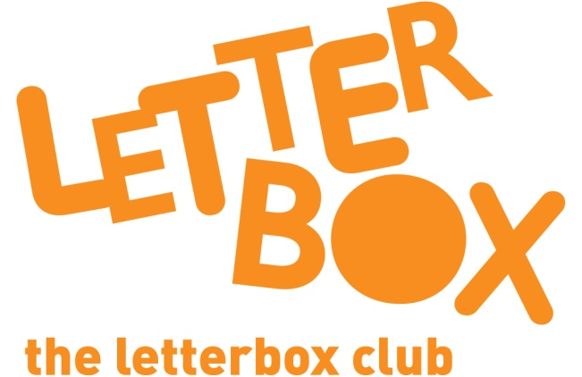

Top Letterbox Tips - Parcel 6

The Letterbox Club provides six, monthly parcels of books, games and stationery for you and your child to enjoy together. It’s run by a reading charity called BookTrust. For more information please visit www.booktrust.org.uk/letterbox-club-families

Here are some ways you might like to use this month’s parcel with your child:

- Encourage your child to take a book with them to read during car, bus or train journeys, or whilst waiting for an appointment.

- We hope you both enjoy The Awesome Night Sky and First Sticker Book: Space. You can find more books about this topic and others by visiting the BookTrust website at www.booktrust.org.uk/books
- If you and your child come across any new words in Splash Day! you could use the pictures to help your child understand the meaning or help them look the word up in a dictionary.

- You can take it in turns to be the shopkeeper and the customer using the Play Shops signs, to help your child with counting and adding money. When it’s your turn to count, encourage your child to count with you. They might need help cutting out the shop signs!

We hope you have both enjoyed being part of the Letterbox Club!
Best wishes,
The Letterbox Club Team

