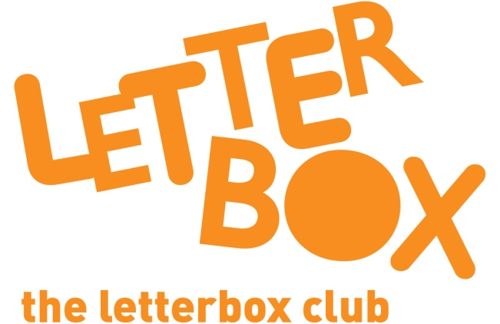

Top Letterbox Tips - Parcel 5

The Letterbox Club provides six, monthly parcels of books, games and stationery for you and your child to enjoy together. It’s run by a reading charity called BookTrust. For more information please visit www.booktrust.org.uk/letterbox-club-families

Here are some ways you might like to use this month’s parcel with your child:

- This month your child has been sent two rhyming stories, including The Dragon and the Nibblesome Knight. This book comes with a CD – you can read along together or even listen in the car.

- You could visit your local library with your child and help them choose a book to borrow. The library might even be holding an event that you and your child could go along to.

- Talking about stories as you read is an important part of sharing books with your child. You don’t have to talk about everything on the page. When reading Emma Jane’s Aeroplane you and your child could talk about where you think Emma Jane will go next or what animal she might find in each country – encourage your child to look at the pictures to help them.

- Squishy Races is a fun game to help your child practise their counting. It can be played alone, but why not have a go together?

Best wishes,

The Letterbox Club Team

