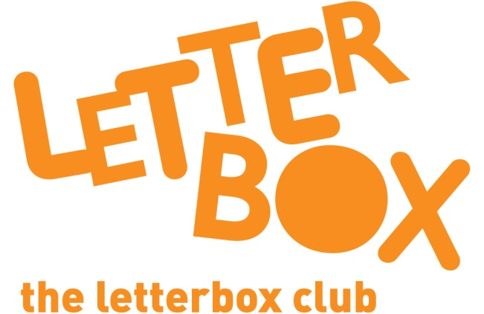

Top Letterbox Tips - Parcel 4

The Letterbox Club provides six, monthly parcels of books, games and stationery for you and your child to enjoy together. It’s run by a reading charity called BookTrust. For more information please visit www.booktrust.org.uk/letterbox-club-families

Here are some ways you might like to use this month’s parcel with your child:

- Your child might have a favourite book that they want to read again and again, rather than trying something new. That’s okay – having a favourite story can help them develop a love of reading.

- When reading How to Nab a Rabbit with your child, look at the pictures together and encourage your child to say what they think will happen next. You may need to help them by pointing out particular things, for example ‘Oh look, there’s a bear. Who is he chasing?’

- We hope your child enjoys My First Drawing, Doodling and Colouring book. They can use the felt pens and notepad in the parcel to practise their drawing if they want to.

- One to Nine Bingo can be played by 2, 3 or 4 people. Why not play together? Your child might need some help with cutting out the bingo cards.

Best wishes,
The Letterbox Club Team

