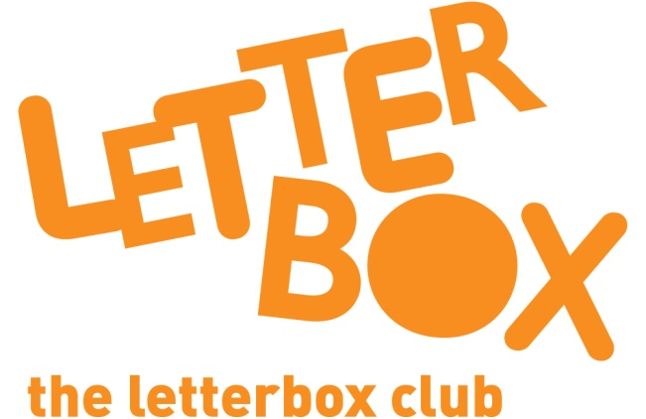

Top Letterbox Tips - Parcel 2

The Letterbox Club provides six, monthly parcels of books, games and stationery for you and your child to enjoy together. It’s run by a reading charity called BookTrust. For more information please visit www.booktrust.org.uk/letterbox-club-families

Here are some ways you might like to use this month’s parcel with your child:

- When reading with your child, encourage them to hold the book and turn the pages themselves.

- After reading How Do Animals Talk? you could help your child draw their own animals using the activity sheet in the parcel.

- When reading The River with your child, talk about the different things you can see on each page. Pointing to them when you talk about them will help your child understand unfamiliar words. You could also help your child count the fish on the last page.

- Play Pairs - After you have played pairs using the cards in the parcel, you could draw your own pairs cards in your child’s exercise book– why not try cards with two faces or four stars?

Best wishes,

The Letterbox Club Team

Did you know? Reading for pleasure can increase empathy, improve relationships with others, reduce the symptoms of depression and improve wellbeing throughout life (The Reading Agency, 2015).

