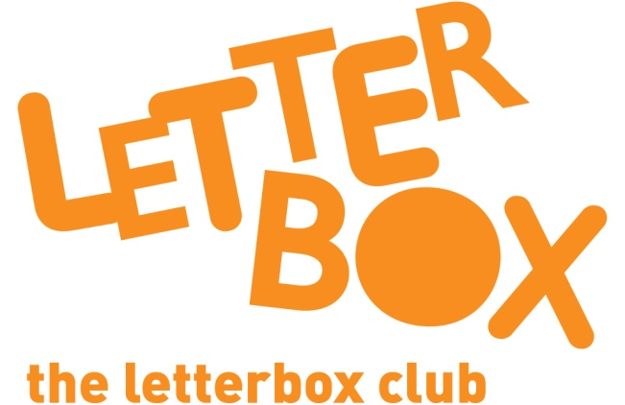

Top Letterbox Tips - Parcel 1

The Letterbox Club provides six, monthly parcels of books, games and stationery for you and your child to enjoy together. It’s run by a reading charity called BookTrust. For more information please visit www.booktrust.org.uk/letterbox-club-families

Here are some ways you might like to use this month’s parcel with your child:

- Remember, reading doesn’t have to be time-consuming. Taking just a few minutes each day to share a story can be a good opportunity to spend time together.

- Encourage your child to choose a book to read with you – this will show them that their opinion matters, and they will be more likely to enjoy a book they have chosen themselves. You may need to narrow down the options to three books, to help them choose.

- This month, your child has been sent Harold Finds a Voice. When reading it with them, don’t be afraid to make the silly sound effects from each page. You can even encourage your child to join in and see who can make the best parrot noise!

- Using their Letterbox Club postcard, you could help your child write to us at the Letterbox Club and let us know what they think about their first parcel.

We hope you both enjoy this month’s parcel.

Best wishes,
The Letterbox Club Team

