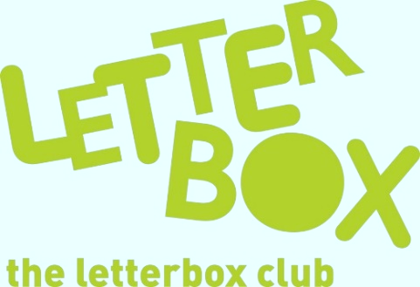

Top Letterbox tips - Parcel 6
The Letterbox Club provides six, monthly parcels of books, games and stationery to children and young people across the UK. It’s run by a reading charity called BookTrust. For more information please visit www.booktrust.org.uk/letterbox-club-families

Here are some ideas for supporting your child with this month’s parcel:
- We’ve sent your child Corpse Talk: Queens and Kings. They’ll find out all about Cleopatra, Henry VIII and other famous royals. Plus, there’s a letter from the authors just for Letterbox Club members. Why not help your child write a letter back? You could also visit your local library or bookshop to find more books in the Corpse Talk series.

- Your child can access the Letterbox Club Members’ Area which contains author content, activities and videos. They don’t need to log in – just type in this link: www.booktrust.org.uk/letterbox-club-members-2
- We hope your child enjoyed their Letterbox Club books, but no matter what their interests are, there are thousands of fantastic books out there to discover and capture their imagination. Why not use BookTrust’s book finder to help them pick their next book? It’s a quick and easy way for you to find great books together that relate to your child’s age and interests: www.booktrust.org.uk/bookfinder
We hope you and your child have enjoyed being part of the Letterbox Club!
Best wishes,
The Letterbox Club Team

