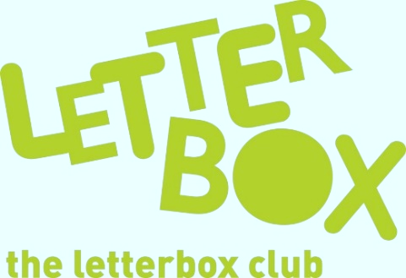

Top Letterbox tips - Parcel 1
The Letterbox Club provides six, monthly parcels of books, games and stationery to children and young people across the UK. It’s run by a reading charity called BookTrust. For more information please visit www.booktrust.org.uk/letterbox-club-families

Here are some ideas for supporting your child with this month’s parcel:
- Your child will receive the £200 game and Double Your Money game. Why not play together? It’s quick to play and you can make it more challenging by setting a time limit.

- You could help your child write an extra chapter for Charlie Merrick’s Misfits - maybe about an extra survival challenge that the group must complete. It doesn’t even have to be written – you could just talk it through.

- Have fun trying the activities in Eye Benders together. Encourage your child to try them out with friends as well!
We hope you and your child enjoy being part of the Letterbox Club.
From,
The Letterbox Club Team
Did you know? Reading for pleasure can increase empathy, improve relationships with others, reduce the symptoms of depression and improve wellbeing throughout life (The Reading Agency, 2015).

