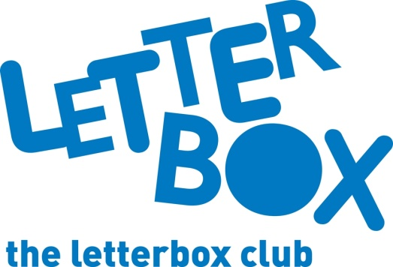

Top Letterbox tips - Parcel 6
The Letterbox Club provides six, monthly parcels of books, games and stationery to children and young people across the UK. It’s run by a reading charity called BookTrust. For more information please visit www.booktrust.org.uk/letterbox-club-families

Here are some ideas for supporting your child with this month’s parcel:

- The Funniest Space Joke Book Ever is a great book for sharing with your child. Tell each other your favourite jokes and use the Crack a Joke activity to help them write their own!

- The Enormous Crocodile is a classic Roald Dahl story. Why not visit the local library to find more books by the same author? You could also help your child write their own story, using ideas in the Write Your Best Story Ever Notebook.

- Letterbox Club Members’ Area - We have included a special card which has login details to the Letterbox Club members’ website containing author content, activities and videos. They don’t need to log in – just help them type in the link on their membership card.

- Remember, there are so many fantastic books out there for your child to discover and capture their imagination. Why not use BookTrust’s bookfinder to help them choose their next book? It’s an easy way for you to find great books together that relate to your child’s age and interests: www.booktrust.org.uk/bookfinder
We hope you and your child have enjoyed being part of the Letterbox Club.
Best wishes,
The Letterbox Club Team

