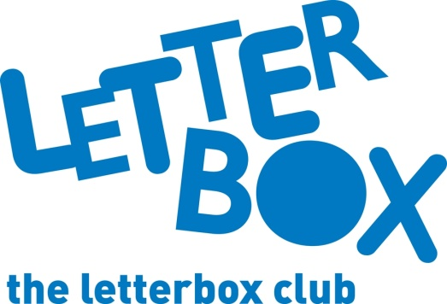

Top Letterbox tips - Parcel 5

The Letterbox Club provides six, monthly parcels of books, games and stationery to children and young people across the UK. It’s run by a reading charity called BookTrust. For more information please visit www.booktrust.org.uk/letterbox-club-families
Here are some ideas for supporting your child with this month’s parcel:
- This month, we’ve sent your child The Invincible Tony Spears – a story about a boy who moves to a new home but then finds that his kitchen transforms into a spaceship! There’s also an exercise book in this month’s parcel so you could encourage your child to note down any fun or interesting words they come across.

- Using their Parakeets postcard, you could get your child to write to us at the Letterbox Club and let us know what they think about the Letterbox Club. We’d love to know about their favourite thing in the parcels!

- Help your child cut out the cards for the Add or Take Away and Elevens games. Encourage them to talk through their calculations and check their answers.
- Keep updated on social media. You can follow @Booktrust on Twitter to find out more about the best new books, and how you can continue to encourage reading for pleasure at home.
Best wishes,
The Letterbox Club Team

