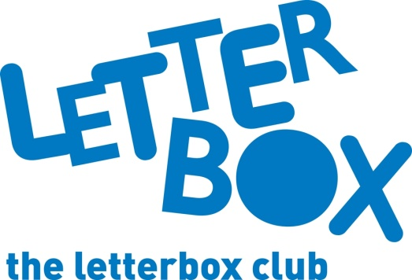

Top Letterbox tips - Parcel 4

The Letterbox Club provides six, monthly parcels of books, games and stationery to children and young people across the UK. It’s run by a reading charity called BookTrust. For more information please visit www.booktrust.org.uk/letterbox-club-families

Here are some ideas for supporting your child with this month’s parcel:
- This month, we’ve sent your child Life on Earth: Ocean. You and your child could quiz each other on some of the fascinating facts!
- There’s also a special Letterbox Club edition of The Phoenix comic for your child – it includes hilarious, short comics that your child can dip in and out of.

- If they like comics, why not encourage them to draw and label their very own comic hero or character. Their character could be inspired by anything… maybe they’ll create a crimefighting giraffe, or a 9-year-old footballer with boots that can make them fly?

- Remember, reading and discussing books with your child has many benefits and will help to develop their confidence across a range of subjects. Taking just a few minutes each day to share a story can be a good opportunity to spend time together.
Best wishes,
The Letterbox Club Team

