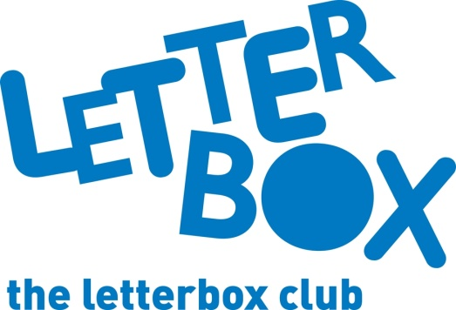

Top Letterbox tips - Parcel 3

The Letterbox Club provides six, monthly parcels of books, games and stationery to children and young people across the UK. It’s run by a reading charity called BookTrust. For more information please visit www.booktrust.org.uk/letterbox-club-families

Here are some ideas for supporting your child with this month’s parcel:
- This month, your child will receive King Flashypants and the Boo-Hoo Witches. If your child enjoys this book, you could visit your local library to find more titles in the series, or ask your local library about similar books.
- We’ve sent your child the Holiday Boredom Buster book. You could complete some of the puzzles together with your child, or encourage them to take it on long car journeys.

- Plus, there are two maths games this month – Counting Cats and Sums Which Make Ten. Play these games with your child and encourage them to count and add out loud. You may need to help your child cut out the games.
Best wishes,
The Letterbox Club Team

Did you know? Children who read for pleasure make significantly more progress in vocabulary, spelling and maths than children who read very little (Sullivan and Brown, 2013)

