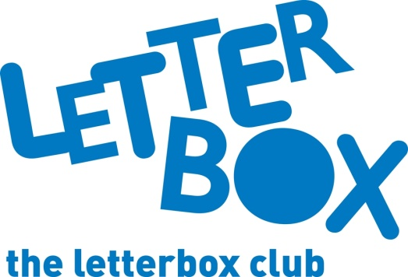

Top Letterbox tips - Parcel 2

The Letterbox Club provides six, monthly parcels of books, games and stationery to children and young people across the UK. It’s run by a reading charity called BookTrust. For more information please visit www.booktrust.org.uk/letterbox-club-families
Here are some ideas for supporting your child with this month’s parcel:
- We’ve sent your child Everything: Volcanoes and Earthquakes, which has a range of incredible facts. This is a great book for sharing - why not pick your favourite facts and talk about them together?

- Your child can use the pencil in this month’s parcel to draw pictures in The Rise of Rusty the Robocat, an interactive doodle book.
- We hope your child enjoys playing Clock Bingo and Tens and Teens Bingo. Why not play this classic game together? Clock bingo is also a great way to help your child practise telling the time. You could build on this by encouraging them to look at different clocks and have a go at telling you the time.
Best wishes,
The Letterbox Club Team
Did you know? Reading for pleasure can increase empathy, improve relationships with others, reduce the symptoms of depression and improve wellbeing throughout life (The Reading Agency, 2015).

