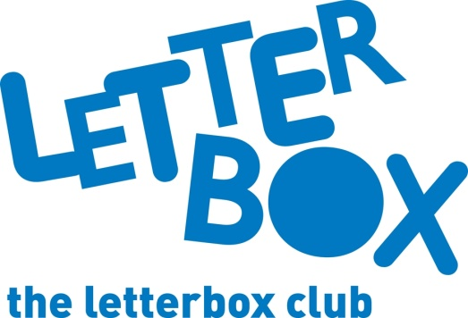

Top Letterbox tips - Parcel 1

The Letterbox Club provides six, monthly parcels of books, games and stationery to children and young people across the UK. It’s run by a reading charity called BookTrust. For more information please visit www.booktrust.org.uk/letterbox-club-families

Here are some ideas for supporting your child with this month’s parcel:
- We’ve sent your child The Cat and the King, a story about a king and his best friend who find a new home after an unfortunate incident with a dragon. Encourage your child to ask you if they don't understand a word and look it up in a dictionary together. It’s great practice for them and will help build their vocabulary.

- When playing Superhero Snap! with your child, talk about the different powers the characters might have and make up superhero names for them. You could talk about a superhero power you would like to have!

- You child can use Drawing Lab: Superheroes and the Superheroes Activity in the parcel to create their own superhero. Together, you could talk about the different adventures their superhero might have, and even turn your ideas into a comic.

- Your child will receive the £30 Game. This is a fun money game that you could play together – it’s quick to play. If your child finds money tricky, you could practise with spare change when you’re on the bus or in a queue.
We hope you and your child enjoy being part of the Letterbox Club.
Best wishes,
The Letterbox Club Team

