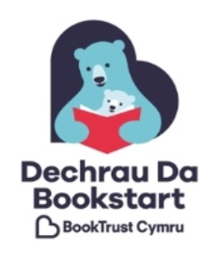
Bookstart Superbox 2017 - Session Diary
This form is for you to record what happened in your Superbox sessions. These diaries will help Book Trust understand how Superbox resources are used and how they make a difference. We will use it to evaluate and improve the current programme.
Please note: Your responses will be kept confidential. Your responses will be made anonymous for any reporting so that you will not be identified.
You are welcome to send us diaries for more than one session. Every form we receive will be entered into a draw to win books for your setting!
Your name |  | Your organisation
Date of session |  | Venue
Length of session |  | Number of families

Are you happy for us to contact you regarding further research? □ Yes □ No
Briefly outline what you did in the session | E.g. I read Clip-Clop once then we read it together as a group using multiple copies. We then made animal props together and read the stories again using the props. We used treasure baskets to explore the story. We ended the session with animal rhymes.
Which Superbox resources did you use? | □Mae Llygoden yn Fach □ Hooray for Fish  □All About Me □Dawns yr Anifeiliaid  □Ideas from conference □Activity cards  □Multiple copies of the books
How useful were the Superbox resources? | □ Very useful □ Quite useful □ Not very useful □ Not at all useful  Please give reasons for your answer:
Briefly describe who the family/ families were | E.g. Families all lived within our rural Flying Start area; some came from outside the UK and approximately 50% had English as an additional language; children were aged 12-24 months.
What do you think was the impact on the family/ families? | E.g. Parents became more confident to join in each time we read the book. They saw their children enjoying using the props – we talked again about how important it is to have fun with books. Some parents commented they had the books at home from their Bookstart packs.
Any other comments

Diolch un fawr iawn – thank you very much!
Please return your form to:
Book Trust Cymru, Business in Focus,
Enterprise House, 127-129 Bute Street,
Cardiff,
CF10 5LE
by Friday 16th December 2017
booktrustcymru@booktrust.org.uk 02920 437839

