Under strict embargo until 00:01 on Thursday 24 September 2020

David McKee wins BookTrust’s prestigious Lifetime Achievement Award
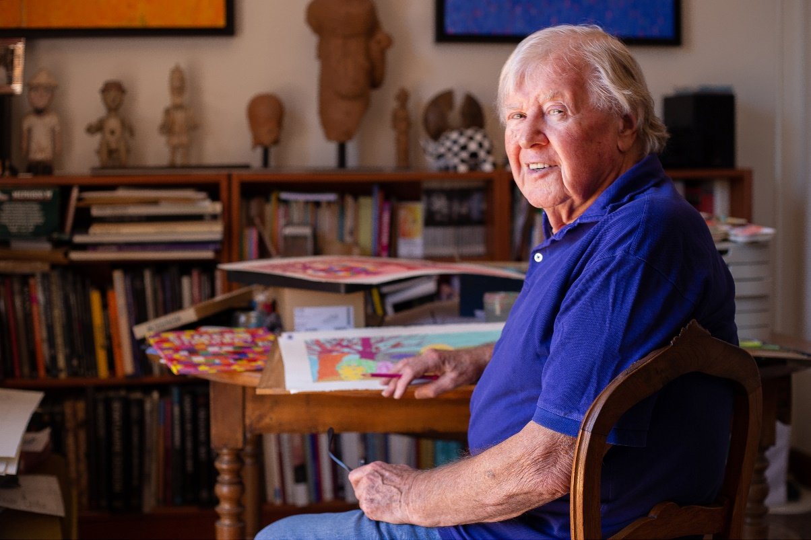

Thursday 24 September 2020 – Today, BookTrust, the UK’s largest children’s reading charity awards the much-loved Elmer and Not Now, Bernard author and illustrator David McKee the winner of its prestigious annual Lifetime Achievement Award.
The BookTrust Lifetime Achievement Award celebrates the body of work of an author and/or illustrator who has made an outstanding contribution to children's literature. Previous winners include Shirley Hughes, the late Judith Kerr, Raymond Briggs, Helen Oxenbury and the late John Burningham, who were awarded the first ever double prize in 2018 and Jan Pieńkowski, the award-winning Polish-born author and illustrator, famous for his iconic Meg and Mog books.
On being recognised for a lifetime achievement award, David said: “The shock is hard to get over and it still doesn’t quite seem possible as I’ve never been one for the spotlight and or winning awards but it’s truly fantastic, and even though I still don’t really believe it, I’m accepting it anyway, with great pleasure.”
David, aged 85, was born in Devon in 1935 and has a career that spans over 60 years. His love of stories and drawing stems from his early childhood. He recalls fondly that lots of people told him stories, and that he loved the tales of Winnie the Pooh and Treasure Island but when thinking about job prospects, the arts didn’t really seem an acceptable career choice, saying “I didn’t even realise being an illustrator could be a real job!” Instead, David decided to take up teaching, however after embarking on a specialist arts teacher training programme at Plymouth College of Art, he decided the classroom wasn’t quite right for him after all and channelled his efforts into creating cartoons and experimenting with writing stories.
In the early part of his career, David regularly drew and sold humorous drawings to magazines and newspapers such as The Times Educational Supplement, Punch, the Reader’s Digest. His first book Two Can Toucan was published by Klaus Flugge in 1964. McKee has written and illustrated over 50 picture books for Andersen Press, many of which are now children’s classics, including King Rollo, Mr Benn, Not Now, Bernard and Elmer the Patchwork Elephant. David loves to paint and now lives between the South of France and London.
David’s books were published at a time when sudden changes in printing techniques allowed for much more colourful picture books and parents started to buy and read children’s books for themselves because they hadn’t seen them before. Elmer remains one of the most iconic and widely read children’s book series of all time, with its bright and bold colours, cast of unique characters and important message of acceptance and celebration of everyone’s differences at its heart. Elmer books have sold over 10 million copies worldwide since first published by Andersen Press in 1989. McKee’s classic picture book Not Now, Bernard, which celebrated its 40th year this June, has sold more than 5 million copies. His iconic Mr Benn celebrates 50 years since appearing on the BBC in 2021, with re-issues of the original book from Andersen Press.
Talking about the importance of children's books, David says: "Children’s books can contribute to changing attitudes and are instrumental in helping them shape their view of the world. Picture books are a child’s first glimpse into the art world and in some way, especially with some of my books, the illustrations are actually more important than the story."
Diana Gerald, CEO of BookTrust said: “David McKee and his patchwork elephant Elmer are synonymous with childhood and loved by children and parents alike. BookTrust is delighted to present David with our Lifetime Achievement Award after such an incredible contribution to children’s literature that crosses cultures, generations and languages.”
The judges for the 2020 BookTrust Lifetime Achievement Award were journalist Nicolette Jones (chairing), author and illustrator James Mayhew, storyteller Jan Blake, author and academic Katherine Rundell and children’s writer SF Said.
Nicolette Jones, journalist and judging chair said: “I’m delighted to have chaired the panel which awarded this year’s BookTrust Lifetime Achievement Award to David McKee. He has an amazing track record since 1964, with books such as King Rollo, Two Can Toucan and of course Elmer. David McKee understands the importance of always paying attention to children and what he gives them is first-rate. I hope readers continue to enjoy his marvellous work for years to come.”
Founder of Andersen Press, Klaus Flugge said: “I have been very proud to publish David McKee’s books for over 50 years; from Elmer to King Rollo, Not Now, Bernard and many, many more. David’s is a singular voice and a shining light in children’s books that highlights inclusivity, diversity and parts of our world that are not always present in children’s books. Not only am I fortunate to be his publisher, he is a great friend, and there is no-one more deserving of this honour.”
To read David’s interview with BookTrust’s Emily Drabble, click here.
[Ends]
Press Contacts: Sinéad Gosai, Press Manager, BookTrust, sinead.gosai@booktrust.org.uk, +44 (0)20 7801 8849
Notes to Editors

Quotes from judges and selected authors and illustrators
Michael Morpurgo
‘It would be enough of a lifetime achievement to have created Elmer for the world, but David has done a great deal more than that. So many bedrooms in this country and all over the world are full of his stories; maybe it’s Mr Benn stories, maybe it’s Not Now Bernard and maybe that ubiquitous patchwork elephant or many, many more. When I think of the millions of people and children and teachers and grandparents who have adored his stories, I know that no-one has deserved this award more.’
Chris Riddell
I first met David when I was young illustrator, and I was reading one of my favourite books by David – Tusk Tusk. I would like to say to David, keep producing these marvellous works and congratulations of a very well deserved BookTrust Lifetime Achievement Award.
Cressida Cowell
You were so much part of my childhood and your work is iconic, and a big part of family life for many. Not Now Bernard is my absolute favourite. A book represents a magical door, and at the end of every story by David, there’s a bit of magic. His career is testament to his imagination and skill.
Lauren Child
I’m so thrilled David has won the Lifetime Achievement Award, he really deserves it. I feel like he’s been with my whole lifetime because I read his books as a child and they were very important to me. Not only because I love the illustrations which were something I’d never seen before. But also because he was always on the child’s side and you felt like these books were for you. As an illustrator I find his work completely inspiring and the design of it is exquisite.
Joseph Coelho
Not Now Bernard has always been one of my favourite picture books – who would have thought you could get away with eating your protagonist!
Sarah McIntyre
I didn’t grow up with David’s work because I didn’t grow up in the UK, but came to it as a grown up and marvel at his approach to creating the story. You can see all sorts of traces of McKee in my studio, thanks for being so amazing David!
SF Said
Delighted to see David’s McKee’s extraordinary body of work being recognised with a Lifetime Achievement Award. I was transfixed as a child by the colours and enthusiasm. There’s a celebration of difference: difference is something to actively celebrate whatever it may be.
Ed Vere
An incredible talent who has been dazzling us for many years. I grew up adoring his books and TV programmes. He really is one of the leading lights of children’s literature and this award could not be more well deserved!
Ken Wilson-Max
What a career for someone whose books are not yet out of print. With David being in his 80s, we can only hope there will be more work to come, congratulations!

BookTrust is dedicated to getting children reading because we know that children who read are happier, healthier, more empathetic and more creative. Their early language development is supported and they also do better at school.
We are the UK’s largest children’s reading charity; each year we reach 3.9 million children across the UK with books, resources and support to help develop a love of reading, because we know that reading can transform lives.
We work with a variety of partners to get children excited about books, rhymes and stories, because if reading is fun, children will want to do it. Our books are delivered via health, library, schools and early years practitioners, and are supported with guidance, advice and resources to encourage the reading habit. booktrust.org.uk
About Andersen Press
Andersen Press is a leading independent children’s publisher, and home to some of the biggest names in the world of children’s books, including the much-loved picture book characters Elmer the Patchwork Elephant and the Little Princess. Andersen Press is the publisher of many award-winning authors and illustrators including Melvin Burgess, Rebecca Stead, Susin Nielsen, Julian Clary, David Roberts, Tony Ross, David McKee, and Jeanne Willis. The company was founded in 1976 by Klaus Flugge.

