Under embargo until Thursday 11th November 2021 at 18:00

Aspiring comedians, polar bears and animal inventors make the line-up as the 2022 Blue Peter Book Awards contenders are revealed
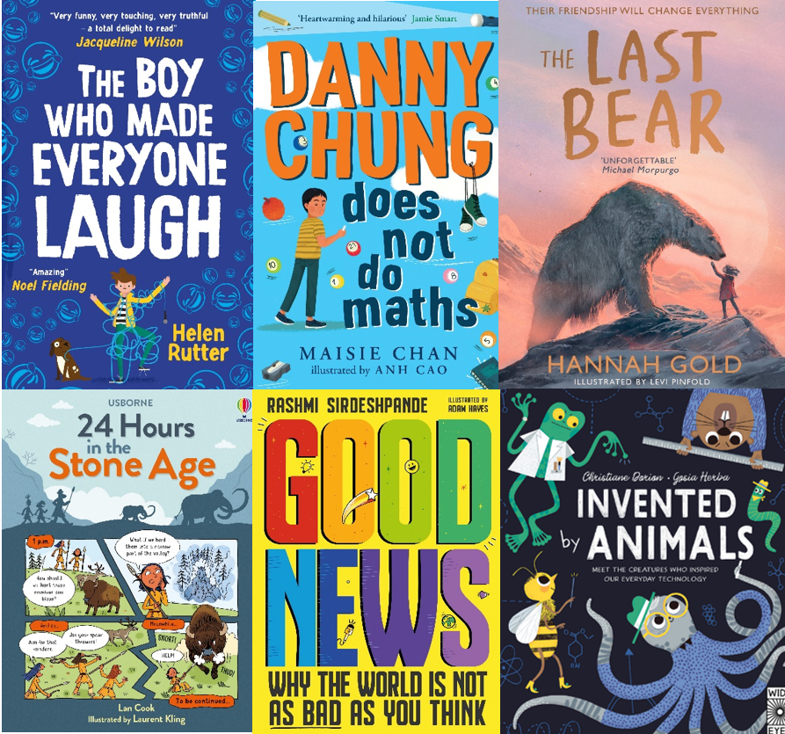
11 November 2021 – Today, BookTrust, the UK’s largest children’s reading charity reveals the six shortlisted titles for the influential 2022 Blue Peter Book Awards, designed to celebrate amazing authors, imaginative illustrators and the greatest reads for primary school-aged children published in the last 12 months.
This year, meet animal inventors changing the world, take a trip to Bear Island, or spend 24 hours in the Stone Age with the books shortlisted for the 2022 Blue Peter Book Awards. The shortlist includes some unforgettable characters, including Danny Chung and his grandmother from China, Billy Plimpton who won’t let his stammer stop him from becoming a comedian, and April who befriends a polar bear a long way from home. In the Best Books with Facts category, there is so much to learn, from which animals invented the best swimming costumes, to finding out about all of the ‘Good News’ out there in the world - from life-saving robots to trees that help heal planet.
All the books on this year’s shortlist are aimed at children between 6 and 12 years old, a vital time when children discover which books they like and build their own independent reading habits.

Competing for the chance to be crowned Best Story are:

- Danny Chung Does Not Do Maths, by Maisie Chan illus. by Anh Cao (Piccadilly Press)
- The Boy Who Made Everyone Laugh, by Helen Rutter (Scholastic Children’s Books)
- The Last Bear, by Hannah Gold illus. by Levi Pinfold (HarperCollins Children’s Books)

The Best Book with Facts titles are:

- 24 Hours in the Stone Age, by Lan Cook illus. by Laurent Kling (Usborne)
- Good News, by Rashmi Sirdeshpande illus. by Adam Hayes (Wren & Rook)
- Invented by Animals, by Christiane Dorion illus. by Gosia Herbia (Wide Eyed Editions)

Judged by a panel of experts who have whittled down a longlist to three books for each category, the final winners will be chosen by more than 300 school children across the country.

Diana Gerald, CEO, BookTrust said: “Congratulations to all of this year’s shortlisted authors and illustrators for creating an incredible selection of books filled with funny and heart-warming stories and awe-inspiring facts. Books provide such an opportunity to touch on important topics that children are interested in, whether it is spotting misinformation, diversity or climate change, and bringing these issues to life in a fun, engaging and entertaining way. At an age when children are starting to grow and develop their interests, the Blue Peter Book Awards play an important role in showing children, families and teachers that there is a book out there to grab the attention of every child, no matter what their interests, and inspire even the most reluctant of readers to pick up a book.
“Now the shortlisted books face their toughest critics yet - the children themselves who will choose the eventual winners. We hope all those children taking part in the judging process will discuss the books with their friends, families and teachers and this can go some way in supporting their reading habits in the future.”
Blue Peter Editor Ellen Evans said: “The Blue Peter Book Awards celebrate the very best new kids’ books. The 2022 shortlist features three outstanding books with facts and three amazing stories. The shortlisted books are inclusive, funny, and about topics that kids care about. Now, over 300 kids take charge to read and review the books and pick the winners.”
The awards are rigorously judged by school children across the country. This year over 1,000 schools applied to be a part of the judging process. The winning titles, voted for by over 300 children from 12 schools across the UK, will be revealed live on Blue Peter in Spring 2022 with the winning authors and illustrators appearing on the special awards episode of the show.
Keep up-to-date with the Awards at www.booktrust.org.uk/bluepeter and on Twitter by following @Booktrust and #BPBA. For fun-filled content about the judging and the shortlisted books head to the Blue Peter website https://www.bbc.co.uk/cbbc/shows/blue-peter
[Ends]
Press Contact: Lizzie Hubbard, Communications Officer, lizzie.hubbard@booktrust.org.uk or press@booktrust.org.uk . 020 7801 8849
Notes to Editors
The Blue Peter Book Awards 2022 judging panel consisted of:
- Caroline Hill-Trevor, Head of Book Purchasing at BookTrust
- Catherine Millar, Founder of Reading for Pleasure consultancy
- Ellen Evans (non-voting chair), Editor of Blue Peter
- Emily Drabble, Head of Children's Books and Prizes at BookTrust
- Jasmine Richards, Founder of Storymix
- Maisie Craddock, Blue Peter’s Presenter Co-Ordinator
- Scott Evans, founder of The Reader Teacher blog, primary school teacher and children’s books consultant
- Simon Hudd, UKS2 Teacher and English Lead, Belleville Primary School
- Soraya Berry, Learning Resource Manager at secondary school
About Blue Peter:
Blue Peter, is the longest running kids TV show in the world featuring Adam, Mwaksy, Richie and Henry the dog. Blue Peter is packed full of challenges, celebrities, and things to do. Every week on CBBC and iPlayer, Blue Peter encourages kids to join in, earn their badge, enter a competition, be creative and adventurous.
For fun-filled content about books and authors head to the Blue Peter website
https://www.bbc.co.uk/bluepeter
Ellen Evans is Editor of Blue Peter, the world’s longest running children’s series, with weekly live shows, an amazing online fan club and Blue Peter badges. A life-long fan of Blue Peter, she worked in bookshops for five years before joining the BBC where she has made factual and entertainment shows for BBC One, BBC Two and BBC Three, CBBC and CBeebies.

About BookTrust:
BookTrust is dedicated to getting children reading because we know that children who read are happier, healthier, more empathetic and more creative. Their early language development is supported and they also do better at school.
We are the UK’s largest children’s reading charity; each year we reach 3.9 million children across the UK with books, resources and support to help develop a love of reading, because we know that reading can transform lives.
We work with a variety of partners to get children excited about books, rhymes and stories, because if reading is fun, children will want to do it. Our books are delivered via health, library, schools and early years practitioners, and are supported with guidance, advice and resources to encourage the reading habit. booktrust.org.uk

Quotes from the shortlisted authors and illustrators:
On being shortlisted for the Blue Peter Book Award, Hannah Gold, author of The Last Bear said: “Growing up, I distinctly remember being glued to Blue Peter, so it gives me immense pride and joy to know that my own book, featuring a rather large and magnificent animal, is now shortlisted for one of the most special book prizes in the UK to be voted for by children. In a time of unprecedented and frightening change facing our planet, we need children's books which offer hope for our future and receiving this kind of honour means Bear's message can be roared far and wide. And for that, I am incredibly grateful. Not just for me, but on behalf of all the wild polar bears everywhere.”

Commenting on what inspired her to write Good News, Rashmi Sirdeshpande said: “I grew up loving comics, picture books, puzzle books and fact books. Anything that sparked that WOW feeling inside me. Anything that carried me away! Because books are the cheapest ticket to absolutely everywhere - real and fantastical. And I love that today especially, there really is something for everyone out there. I wrote Good News to give young readers the facts about the biggest challenges we face on this planet but also the facts about how far we've come already, how much amazing work is being done, and how we have so many reasons to be hopeful about the future. Good News is the hardest, truest, most important thing I've ever written and to see it shortlisted for this incredible award means everything to me. Everything.”

Maisie Chan, author of Danny Chung Does Not Do Maths, said: “I am totally amazed and can't believe it! It means so much to me to be shortlisted for this particular award. I used to watch Blue Peter as a child and my children watch it, I am also so happy that Danny Chung Does Not Do Maths has made an impression. I hoped it would and for someone of British Chinese descent like me, it's a big deal to have my novel nominated for this amazing award. It's my homage to my home city of Birmingham, and I'm so happy to see a British Chinese boy on the cover of my book and that people seem to love Nai Nai, his grandmother.”

Levi Pinfold illustrator of The Last Bear said: “Who’d have thought reading too many comics as a kid would lead to the shortlist for a Blue Peter book award! It's amazing to be a part of Hannah's wonderful book. To me, good stories are the ultimate enjoyment. It doesn’t matter what kind of person you are, you can guarantee someone has written a story which will grab you and not let go, something that feels like it’s just for you. It’s a thrill to celebrate something that can give so much pleasure. And to those of you who might be sitting on the fence about picking up a book: Take a chance, try something that looks good, it can change your life! It did mine.”

Helen Rutter, author of The Boy Who Made Everyone Laugh, said: “I did a little dance around my kitchen when I found out that I was shortlisted for this award, I may have even made up a little song (but don’t ever ask me to sing it). I love books that make me smile, laugh, think and cry and that is what I tried to create with The Boy Who Made Everyone Laugh.
“When I was a kid, I read the same books over and over and never got bored. When you find a book you love it becomes like a friend. Even if you have not yet found a book you love, it's out there somewhere and when you find it you will know, you just have to keep looking. The idea that there might be kids out there who feel that way about my story makes me so so happy… in fact I may need to do a little dance again!’”
Lan Cook, author of 24 Hours in the Stone Age said: “I’m delighted to have been shortlisted for the Blue Peter Book Awards. I loved watching Blue Peter as a child, and to have a book recognised by them is a huge honour. As a child I found comics so welcoming, and the worlds they create incredibly immersive, to be able to write books like this really is a dream.”
Adam Hayes, illustrator of Good News, said: “Being shortlisted is a huge surprise, and definitely not something my younger self would have imagined as he was scrawling over his school books. I'm just really grateful to be part of Rashmi’s book, and play my part in helping kids learn through reading. Oh, and my kids might even think their dad is ‘cool’ for a few minutes!”
Commenting on why she writes children’s books Christiane Dorion, author of Invented by Animals, said: “As a child, I loved being in nature and was always interested in how things work. Books helped me to understand the world around me and made me even more curious. Books can be fun, informative and inspiring. They can change you and you can change the world. Books open your mind to new worlds and adventures. Today there is such a huge variety of fantastic books – fiction and non-fiction. My passion is to write about the wonderful planet we live on. I love writing books that you don’t necessarily have to read from beginning to end in one go. It’s nice to be able to dip in and out, look at the pictures and go for the bits of text that you find interesting.”
Gosia Herba, illustrator of Invented by Animals, said: “I've been a bookworm since I was a child. I believe that books helped me make my dreams come true. Thanks to them, I discovered art and eventually decided to become an illustrator. Books bring not only knowledge but also lots of fun, adventures and inspiration. Reading makes our lives fuller and happier! I am delighted! Thank you! It gives me faith in the purpose of my work. Drawing children books fulfils my life. When creating books, I'm always accompanied by the thought that my work will become part of another person's life. That's why I always try to develop friendly, inclusive worlds where every reader, young and old, will find a place for himself. I'm glad to see the effort appreciated.”

