BookTrust Cymru launches week of rhymes and stories to boost children’s wellbeing and support families during lockdown

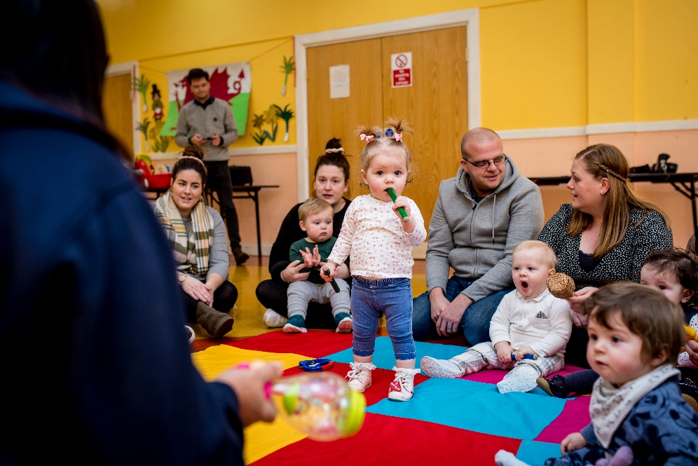

This week, thousands of children will be taking place in BookTrust Cymru’s annual Big Welsh Rhyme Time. The week is a celebration of sharing rhymes, songs and poems in the early years.
With increasingly concerning reports emerging about the impact of successive lockdowns on families and the widening development gap for some children, the charity has designed this week to engage families, teachers and early years practitioners in fun activities that can help develop language, social and communication skills as well as improving wellbeing. The Big Welsh Rhyme Time is the latest in the charity’s initiatives to support children and families – and those who work with them – during the Covid crisis, which has also included distributing over 26,000 books to families in most need in Wales since April 2020.
This year, the Big Welsh Rhyme Time will focus on the fun of rhymes with newly commissioned Welsh, English and bilingual rhymes and songs for children to join in with and enjoy, available online throughout the week. Over 21,000 children have already been registered to take part, with many more expected to join in through online and in-person sessions run by schools, libraries, nurseries, Cylchoedd Meithrin and play groups.
Helen Wales, Head of BookTrust Cymru, said: “This has been a really tough winter and the Big Welsh Rhyme Time is all about giving young children and families fun and simple rhymes and songs that they can enjoy together. It’s easy to think that children’s rhymes and songs are a bit silly or ‘just for fun’, but these are easy and accessible activities with significant developmental benefits for young children. They can help develop language and communication skills, improve listening and attention skills and build children’s confidence to speak up and join in. We also hope the Big Welsh Rhyme Time will help children to have some much-needed memorable shared experiences together to boost their spirits during these challenging times.”
The rhymes and songs, which have been created by five artists, explore different themes and styles, from simple songs to beat-based spoken word. Sean Chambers will be running online drawa-along sessions based new rhymes about monsters; Laura Bradshaw and Joseph Gnagbo will share the multi-lingual ‘Bore Da, Little Bee’ by; there will be adventures in outer space with Iwan Garmon; and the poet Rufus Mufasa will share new work inspired by rainbows.
With growing concerns that some children from English-speaking homes are missing out on access to the Welsh language during lockdown, the new works have been commissioned to give children new experiences of hearing rhymes and songs in Welsh, English and bilingually. They include pieces originally composed in Welsh and translated into English, and vice versa, as well as new bilingual works.
Sean Chambers, children’s author and illustrator, said: “An early introduction to rhyming is a fantastic way to develop creative skills. It not only encourages children to think about their choice of words but also how those words fit together.”
Rufus Mufasa, poet and musician, said: “Words make our world bigger. Poetry makes it magic...”
The Big Welsh Rhyme Time supports BookTrust’s well-established programmes in Wales, Bookstart and Pori Drwy Stori. Both programmes are funded by Welsh Government and available free of charge for every child in Wales, with children, families and schools receiving free resources and books to have fun with reading and sharing rhymes in the early years.

To find out more click here or follow us on twitter @BookTrustCymru
[Ends]
Press Contacts: Sinéad Gosai, Press Manager, BookTrust, sinead.gosai@booktrust.org.uk, +44 (0)20 7801 8849
Notes to Editors
BookTrust is dedicated to getting children reading because we know that children who read are happier, healthier, more empathetic and more creative. Their early language development is supported and they also do better at school.
We are the UK’s largest children’s reading charity; each year we reach 3.9 million children across the UK with books, resources and support to help develop a love of reading, because we know that reading can transform lives.
BookTrust Cymru is the organisation’s office in Wales. We work with a variety of partners to get children excited about books, rhymes and stories, because if reading is fun, children will want to do it. Our books are delivered via health, library, schools and early years practitioners, and are supported with guidance, advice and resources to encourage the reading habit. booktrust.org.uk/cymru

