Under embargo until 00:01 Monday 11th October
BookTrust to support 740,000 children to make ‘Time to Read’ as they adjust to starting primary school
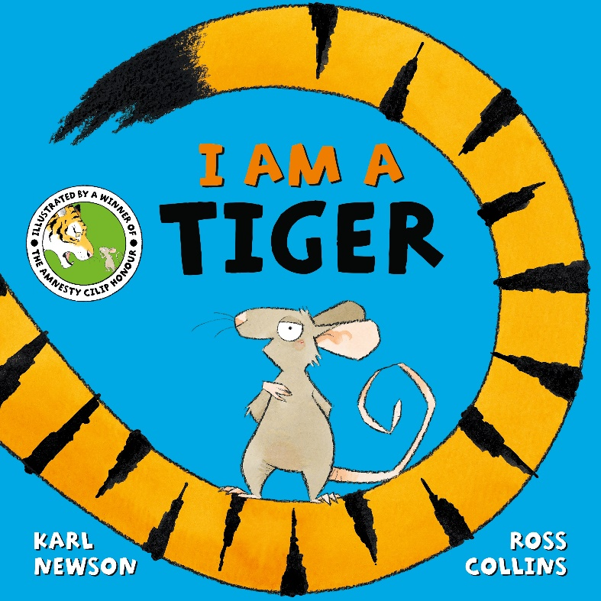
BookTrust, the UK’s largest children’s reading charity launches its sixth annual Time to Read campaign which aims to encourage children and families to continue reading together even when children start school and learn to read independently.
From November, BookTrust will be sending out Time to Read packs to every reception child in England and every primary one child in Northern Ireland, reaching a total of 740,000 children.
For children aged 4-5, starting school for the first time means establishing new routines at home, and often learning to read and tasks set by school can be prioritised over reading together with their families. Time to Read is designed to encourage families to relax and continue reading together with their children at this critical transition point.
This year, the Time to Read pack includes a free copy of I Am A Tiger by Karl Newson and Ross Collins, published by Macmillan Children’s Books, alongside some top tips for reading together.
With its simple text and bold illustrations, this is a lovely book to read aloud and to share. It’s a funny story about an adventurous mouse that can be taken at face value, yet also subtly raises the concept of labels and how they are applied.
With creative ideas for sharing stories as a family, the Time to Read pack aims to spark children’s imagination, help improve their language and listening skills as well as develop more practical skills aligned to starting school, such as making new friends and dealing with change.
Thanks to its unique partnerships with local authorities in England and the Education Authority in Northern Ireland, BookTrust is distributing Time to Read packs through schools and libraries and encouraging families to continue sharing stories together throughout the autumn term.
The packs will include information about the book, ideas for teachers to introduce the books to their classes and a digital toolkit to help them spread the word.
Diana Gerald, BookTrust’s Chief Executive said: “The last 18 months have been incredibly difficult for everyone and especially for families with young children. Starting school can be a challenging experience for children at the best of times, yet this year’s intake will have missed out on so many of the early education and social development opportunities that can prepare children for this big step in their life.
“With families facing multiple pressures at this time, reading together can be overlooked, especially as children start to learn to read independently in school. We hope sharing the fantastic book I Am A Tiger inspires families to read together, offering them a chance to connect, spend quality time together and relax.”
Belinda Ioni Rasmussen, Managing Director at Macmillan Children's Books said: "We are absolutely thrilled to be working with BookTrust on this brilliant and important initiative designed to ensure that families read together. Time to Read truly sparks children's imaginations, improves language and creates a love of reading which goes beyond the classroom.
“Karl Newson and Ross Collins's I am Tiger is a perfect choice: an original and hilarious story about an adventurous mouse with big ideas. The vibrant artwork from Ross and wonderful characters from Karl will entertain families across the country and we hope this story will encourage children to embark on a lifetime of reading for pleasure."
Karl Newson said: "I am squeaking with delight to know that I Am A Tiger has been selected for BookTrust's Time to Read! This little mouse has taken me on some wild adventures and to know that the book will be shared by so many families in so many places is a fantabulous honour. I hope it is something that everyone will enjoy and that it will make some magical times for everyone, too. Thank you BookTrust. Thank you, Ross. Thank you, Macmillan Children's Books. Thank you, Mouse!"
“I used to read to my children every night, and it was something I really looked forward to: a coming together to share in something just for us, be it with giggles or by sharing hearts, it was always wonderful and magical. My children are now almost as old as I am, but I still show them every new story I write. It's all for them in the end, them and those magic times we get together.”
Ross Collins said: "It’s a real honour having I Am a Tiger chosen for this year’s Time to Read. To know that our book will be gifted to thousands of children who have limited access to books is a great gift for me too. I hope our silly mouse puts a smile on lots of small faces.
“We’ve read to our son every night since he was born – he’s six now. It’s not always easy being either a parent or a small boy but having that quiet time at the end of each day with a story to bring you together is really important for us. Books have brought us closer, sparked his imagination, begun conversations and has given him the vocabulary of a thirty-year-old.”
For more information on Time to Read visit: booktrust.org.uk/TTRCampaign.
To watch a video of Karl Newson and Ross Collins reading I Am a Tiger visit: youtube.com/watch?v=Un-RT-70ZRI
ENDS
Press Contacts: Lizzie Hubbard Comms Officer at BookTrust, lizzie.hubbard@booktrust.org.uk or press@booktrust.org.uk +44 (0)20 7801 8849
Notes to Editors
About BookTrust
BookTrust is dedicated to getting children reading because we know that children who read are happier, healthier, more empathetic and more creative. Their early language development is supported and they also do better at school.
We are the UK’s largest children’s reading charity; each year we reach 3.9 million children across the UK with books, resources and support to help develop a love of reading, because we know that reading can transform lives.
We work with a variety of partners to get children excited about books, rhymes and stories, because if reading is fun, children will want to do it. Our books are delivered via health, library, schools and early years practitioners, and are supported with guidance, advice and resources to encourage the reading habit. Booktrust.org.uk

About Pan Macmillan
Pan Macmillan is the UK general book publishing arm of the Macmillan Group, which operates in over 70 countries. Its imprints include Macmillan, Mantle, Pan, Picador, Bluebird, One Boat, Tor, Macmillan Children's Books, Macmillan Collectors Library, Kingfisher, Campbell Books and Two Hoots. Pan Macmillan was named Publisher of the Year at The Bookseller Industry Awards in May 2015, May 2017 and again in June 2020.
panmacmillan.com

Ross Collins studied illustration at the Glasgow School of Art, graduating in 1994 and in the
same year he won the Macmillan Children’s Book Prize for the The Sea Hole. Since then, he
has gone on to illustrate over 130 books and has written several too. His picture book The
Elephantom was shortlisted for the Kate Greenaway Medal and was staged at London's
National Theatre. His best seller There's a Bear on My Chair won the inaugural Amnesty CILIP
Honour. When Ross is not creating children’s books he enjoys working on character
development for animation studios such as Laika and Disney. He lives in Glasgow with his partner,
his young son, and a destructive labrador puppy.
Ross Collins studied illustration at the Glasgow School of Art, graduating in 1994 and in the
same year he won the Macmillan Children’s Book Prize for the The Sea Hole. Since then, he
has gone on to illustrate over 130 books and has written several too. His picture book The
Elephantom was shortlisted for the Kate Greenaway Medal and was staged at London's
National Theatre. His best seller There's a Bear on My Chair won the inaugural Amnesty CILIP
Honour. When Ross is not creating children’s books he enjoys working on character
development for animation studios such as Laika and Disney. He lives in Glasgow with his partner,
his young son, and a destructive labrador puppy.
Ross Collins studied illustration at the Glasgow School of Art, graduating in 1994 and in the
same year he won the Macmillan Children’s Book Prize for the The Sea Hole. Since then, he
has gone on to illustrate over 130 books and has written several too. His picture book The
Elephantom was shortlisted for the Kate Greenaway Medal and was staged at London's
National Theatre. His best seller There's a Bear on My Chair won the inaugural Amnesty CILIP
Honour. When Ross is not creating children’s books he enjoys working on character
development for animation studios such as Laika and Disney. He lives in Glasgow with his partner,
his young son, and a destructive labrador puppy.
Karl Newson is an award-winning talented name in children’s books from Norwich, Norfolk. He writes stories on a variety of topics, from quiet bedtime reads, to wild and wondrous tales. Karl's books are published in over 25 languages around the world and have been shortlisted for the Booktrust Storytime Prize, Sainsbury's Children's Book Award and the Alligator's Mouth Award, among others. When Karl isn’t writing he enjoys walking in woods, listening to music and reading nonsense poetry. He lives in London with his family and a forest of pot plants. Karl is the author of The Same But Different Too, I Really REALLY Need a Wee, The Hat Full of Secrets, How to Mend a Friend, and A Bear is a Bear. As well as I am A Tiger, Macmillan Children’s Books also published I am Not an Elephant and I can Roar Like a Dinosaur. Karl tweets at @karlwheel

Ross Collins studied illustration at the Glasgow school of Art, graduating in 1994 and in the same year he won the Macmillan Children’s Book Prize for The Sea Hole. Since then he has gone on to illustrate over 130 books and he has written several too. His picture book, The Elephantum was shortlist for the Kate Greenaway Medal and staged at London’s National Theatre. His best seller There's a Bear on My Chair won the inaugural Amnesty CILIP Honour. When Ross is not creating children’s books he enjoys working on character development for animation studios such as Laika and Disney. He lives in Glasgow with his partner, his young son and a destructive Labrador puppy.

Ross Collins studied illustration at the Glasgow School of Art, graduating in 1994 and in the
same year he won the Macmillan Children’s Book Prize for the The Sea Hole. Since then, he
has gone on to illustrate over 130 books and has written several too. His picture book The
Elephantom was shortlisted for the Kate Greenaway Medal and was staged at London's
National Theatre. His best seller There's a Bear on My Chair won the inaugural Amnesty CILIP
Honour. When Ross is not creating children’s books he enjoys working on character
development for animation studios such as Laika and Disney. He lives in Glasgow with his partner,
his young son, and a destructive labrador pup

