Reception aged kids to explore ‘The Cave’
700,000 copies of The Cave to be given out for BookTrust’s Time to Read campaign
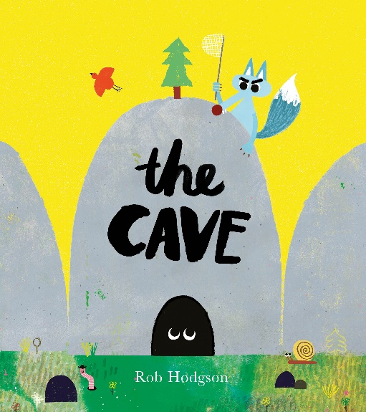
1st May 2019 – School starters in England will receive their very own copy of the book The Cave this September as part of BookTrust’s annual Time to Read campaign.
Now in its fourth year, the Time to Read campaign from the UK’s largest children’s reading charity encourages families to make time to read together, share stories every day and find the fun in reading.
This quirky picture book tells the tale of a curious, persistent and very hungry wolf and a secret little creature that will keep kids guessing. The Cave is a laugh-out-loud story with a very BIG surprise accompanied with glorious artwork, bursting with colour and warmth. Written and illustrated by the renowned Rob Hodgson, The Cave (Frances Lincoln Children’s Books) teaches a very important lesson about perspective and not to judge others too quickly.
BookTrust Chief Executive Diana Gerald said: “This colourful, humorous and entertaining book will get children excited about stories. BookTrust aims to ensure that all children, regardless of their background, have access to books and enjoy the magic that stories can bring to their lives. The Cave is beautifully illustrated and perfect to get little ones giggling, asking questions and having fun.”
A panel of experts chose The Cave because of its vibrant and fun illustrations, its mystery, humour and great messages of persistence and not underestimating the people around you. It’s also a great book to keep kids guessing, using their imagination and talking about the seasons.
Rob Hodgson, author and illustrator of The Cave commented:
Being selected for the BookTrust Time to Read campaign is a huge honour. I never could have imagined that the book (and the worm!) would get to reach so many people’s lives. I don’t think I’ll ever wrap my head around what that many books looks like and I’m so very humbled that The Cave will be the first book that some kids ever own.”

Every reception age child in England will start receiving The Cave at school from September. The book is delivered inside a special Time to Read pack that each child gets to keep and take home. Inside each pack is a message for families about the importance of shared reading, alongside practical tips and advice to help them bring the story to life at home. booktrust.org.uk/timetoread
Katie Cotton, Publisher for Picture Books, Frances Lincoln Children’s Books commented: “In a time of library cuts and squeezes to school budgets, the BookTrust Time to Read campaign is more important than ever in ensuring that young children have access to stories. We are simply thrilled that The Cave has been chosen as the story to start them off on their reading adventure. We hope that this funny story will teach children everywhere not to take everything at face value… and show them that life is full of surprises!”

[Ends]
Press Contacts: Emily Grigg, Press Officer, BookTrust, emily.grigg @booktrust.org.uk, +44 (0)20 7801 8848
Notes to Editors
BookTrust is dedicated to getting children reading because we know that children who read are happier, healthier, more empathetic and more creative. Their early language development is supported and they also do better at school.
We are the UK’s largest children’s reading charity; each year we reach 3.4 million children across the UK with books, resources and support to help develop a love of reading, because we know that reading can transform lives.
We work with a variety of partners to get children excited about books, rhymes and stories, because if reading is fun, children will want to do it. Our books are delivered via health, library, schools and early years practitioners, and are supported with guidance, advice and resources to encourage the reading habit. booktrust.org.uk
Rob Hodgson was born in a seaside town in the south of England in 1988. He studied Illustration at Plymouth University. Today, he lives in Bristol, where he spends his time making a mess and turning it into illustration projects, quality paper goods and books. He cites Picasso, John Cage and The Beach Boys among his influences. Working with traditional processes and lo-fi techniques such as block printing, paper cutting and wood cut, Rob combines old and new ideas to create his work. Some interests include animals, skateboards, the psychology of perception and collecting strange toys. His first author-illustrated book, The Cave, was published in 2017 to wide acclaim and has since sold in 10 languages. The Woods is his second picture book and was released in April 2019.
Frances Lincoln Children's Books is an imprint of The Quarto Group — a leading global illustrated book publisher and distribution group, publishing in over 50 countries and 40 languages. The Group was founded in London in 1976 and produces books for the whole family.

