Candy Gourlay announced as BookTrust’s new Writer in Residence

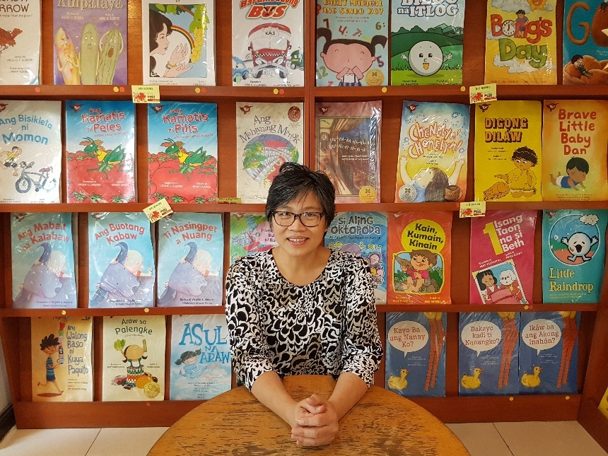

A focus on windows and mirrors as Candy Gourlay takes the reins

Monday 11th March – Award winning children’s author, Candy Gourlay, has been appointed the new online Writer in Residence for the UK’s largest children’s reading charity, BookTrust.

Philippines-born and London-based, Candy is well-known for her books Bone Talk, Is It a Mermaid (illustrated by Francesca Chessa) Shine and Tall Story. Having been nominated for top industry prizes including the Guardian Children’s Book Prize, the Carnegie Medal, the Waterstones Children’s Book Prize, the Blue Peter Book Award and the Branford Boase Award, Candy is a wonderful choice to be BookTrust’s next Writer in Residence.

During her six-month residency, Candy will share her ideas to help inspire readers of all nationalities and backgrounds and will be exploring the theme of books as both windows and mirrors to the world.

Candy Gourlay says about her residency at BookTrust:

“I’m incredibly excited to be invited as BookTrust's Writer in Residence! Growing up in the Philippines in uncertain times made me think I would probably never get a chance to see the world. But books proved me wrong. Between the covers of books, I travelled all over the world, met the most extraordinary characters and learned that there were more ways to live than I knew. Someone said books are windows and mirrors. Windows because they allow you to look beyond your own experience. Mirrors because they reflect the universality of humanity. Windows and Mirrors – as BookTrust's Writer in Residence, I hope everyone will join in exploring this theme.”

Highlights of Candy’s residency will include a creative writing competition for primary schools and an exciting book event for Filipino children in London.

Diana Gerald, BookTrust CEO said:

“In a time where supporting author diversity is critical, we are incredibly lucky and excited to have an author with such personal lessons and stories to share. Candy is not only a brilliant author but also an important role model to inspire children to both read and write. The BookTrust online Writer in Residence programme is a wonderful feature, giving visitors to the BookTrust website an invaluable insight into the lives, minds and sketchbooks of acclaimed illustrators and writers. We hope children across the country will be able to learn about the world but also learn to use books as windows to discover new opportunities and adventures.”

The BookTrust Writer in Residence project has been running since March 2009 and has featured authors and illustrators including Nadia Shireen, Cressida Cowell, Nicola Davies, Sita Brahmachari, Patrick Ness, Polly Dunbar, Bali Rai, Matt Haig, Laura Dockrill, Chris Riddell, Sarah McIntyre, Philip Ardagh, Taran Matharu and Phil Earle. The residency encourages each writer or illustrator to explore topics that they are passionate about, with past residents exploring themes such as the power of stories, diversity in children’s literature and the importance of libraries.

Keep up-to-date with all of Candy’s blogs here.

ENDS

Press contacts

Emily Grigg
Press Officer, BookTrust
emily.grigg@booktrust.org.uk 020 7801 8848

Notes to Editors
BookTrust is dedicated to getting children reading because we know that children who read are happier, healthier, more empathetic and more creative. Their early language development is supported and they also do better at school.
We are the UK’s largest children’s reading charity; each year we reach 3.4 million children across the UK with books, resources and support to help develop a love of reading, because we know that reading can transform lives.
We work with a variety of partners to get children excited about books, rhymes and stories, because if reading is fun, children will want to do it. Our books are delivered via health, library, schools and early years practitioners, and are supported with guidance, advice and resources to encourage the reading habit. booktrust.org.uk

Candy Gourlay

Candy Gourlay’s third novel, Bone Talk, and her first picture book, Is It a Mermaid (illustrated by Francesca Chessa), were published last year to prize listings – including the Costa Book Award – and glowing reviews. Growing up in the Philippines at a time when most books were imported from the West, Candy Gourlay wondered why all the books she ever loved only featured pink-skinned children who lived in snow-covered worlds that didn’t resemble her steamy, tropical home in Manila. As a result, she took many detours on her way to becoming an author. She worked as a journalist, a cartoonist, a fake American voice over talent, and a web designer – before finally becoming an author of children’s books.

It took her years not just to fulfil her dream of becoming an author but to learn that Filipino stories too, belong between the covers of books. Candy’s first middle grade novel, Tall Story – set partly in the Philippines and partly in the United Kingdom – is about siblings who are separated by paperwork and magic. It was nominated for the Carnegie Medal as well as the industry’s top prizes: the Waterstones, the Blue Peter, and the Branford Boase. Her second book, Shine – a ghost story – was listed for the Guardian Children’s Book Prize. Both novels won the Crystal Kite Prize. Bone Talk is set in a historical moment in the Philippines when headhunting tribes came face to face with American invading forces for the first time. Her first picture book, Is It a Mermaid, is set in an idyllic white sand island typical of the Philippines, with a heartfelt eco message.

Candy is an ardent member of the international children’s literature organisation, the Society of Children’s Book Writers and Illustrators (SCBWI). She is currently serving on the Children’s Writers’ and Illustrators’ Group of the Society of Authors. She lives in London with her family, where she wages war on the snails in her garden.

