Embargo Monday 27th May 2019 12:00pm

First ever BookTrust Storytime Book Prize shortlist unveiled
Tales of pet dragons, tantalising treats and hungry beasts have made the cut as the shortlist for BookTrust’s Storytime Prize is revealed
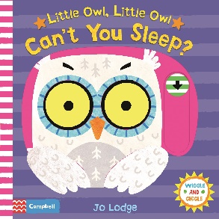
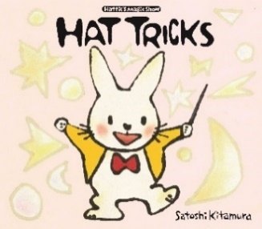
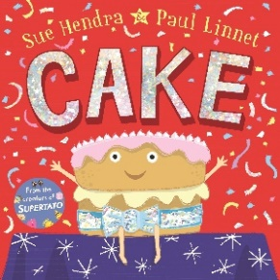
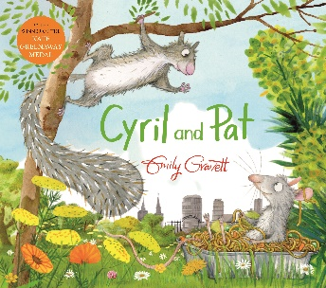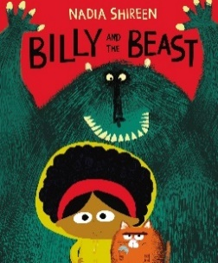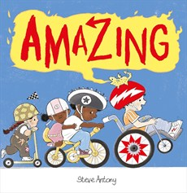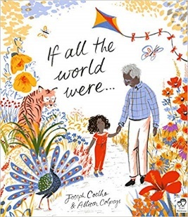

Monday 27 May – BookTrust, the UK’s largest children’s reading charity, today unveiled the first ever ‘BookTrust Storytime Prize’ shortlist for its brand-new award to celebrate the best books for sharing with babies and children aged 0-5.
Stories of pet dragons, tantalising treats and hungry beasts have made the shortlist for BookTrust’s Storytime Prize. The seven books chosen by a panel of expert judges transport children into new worlds and teach them about inclusivity, friendship, family and the world.
The judges, Baroness Floella Benjamin, illustrator James Mayhew and librarians Amy McKay, Alison Brumwell, Jake Hope, Joy Court and Julia Hale had the tough task of deciding the seven shortlisted books which were announced at Hay Festival in a special event hosted by Baroness Floella Benjamin and guests - Nadia Shireen, Steve Antony, Sue Hendra and Paul Linnet plus Emily Gravett which celebrated the joy of sharing stories.
BookTrust’s Storytime Prize Shortlist:
- Cyril and Pat by Emily Gravett
- Billy and the Beast by Nadia Shireen
- Cake by Sue Hendra and Paul Linnet
- Amazing by Steve Anthony
- Can’t you Sleep Little Owl by Jo Lodge
- Hat tricks by Satoshi Kitamura
- If All the World Were by Joe Coelho and Allison Colpoys

Judge Baroness Floella Benjamin OBE commented: “Narrowing the shortlist was an incredibly difficult decision, so difficult that we added a 7th book to the shortlist! We hope that the stories we’ve chosen will make kids (and adults) laugh, sing, dance and snooze. These books set the perfect platforms to start conversations about the importance of understanding and acceptance and will give families the perfect opportunity to bond. We cannot wait to see what the public decide!”

Diana Gerald, BookTrust CEO said “This is a truly exciting collection of shortlisted stories for our inaugural BookTrust Storytime Prize, the judges have certainly chosen well. The books each celebrate individuality and diversity while reminding kids of important life-long lessons. At BookTrust we are always thrilled to share inspiring books for little ones and to celebrate the amazing children’s authors and illustrators out there.”

Emily Gravett, author and illustrator commented, “I am over the moon that my book ‘Cyril and Pat’ has been shortlisted for the BookTrust Storytime Award. I’m sure I speak for all the authors when I say I’m honoured to be shortlisted for such an incredible new prize. I’m especially excited because the award promotes the sharing of books, which is something that I feel is incredibly important in a young child’s development.”

The award is run in partnership with Youth Libraries Group, and over the 2019 summer holidays, the seven shortlisted books will be shared with children, carers and families by public librarians from each of the nine English regions (organised in partnership with the Youth Library Group), along with Wales and Northern Ireland, to find the best book for sharing.

Chair of Youth Libraries Group and shortlist judge Jake Hope commented: “As the Chair of the Youth Libraries Group, I know just how important sharing stories with young children is as it contributes massively to early learning, to bonding and to the development of safe attachment, all of this and it is such good fun for all involved. It's a true delight to be working with BookTrust on the new Storytime prize which recognises every aspect of this and gives the young readers and families such a positive and pleasurable experience of books, reading and libraries.”

The winning book will be announced at a special ceremony in London in November 2019, with a prize of £5000.

[Ends]
Press Contacts: Emily Grigg, Press Officer, BookTrust, emily.grigg@booktrust.org.uk, +44 (0)20 7801 8848
Notes to Editors
BookTrust is dedicated to getting children reading because we know that children who read are happier, healthier, more empathetic and more creative. Their early language development is supported and they also do better at school.
We are the UK’s largest children’s reading charity; each year we reach 3.4 million children across the UK with books, resources and support to help develop a love of reading, because we know that reading can transform lives.
We work with a variety of partners to get children excited about books, rhymes and stories, because if reading is fun, children will want to do it. Our books are delivered via health, library, schools and early years practitioners, and are supported with guidance, advice and resources to encourage the reading habit. booktrust.org.uk
Author/ Illustrator Biographies
- Steve Antony is an award winning, bestselling children's book writer and illustrator based in Swindon in the UK. His 2014 debut, The Queen's Hat, won the Oscar's First Book Prize, was nominated for the Kate Greenaway Medal and shortlisted for a clutch of awards, including the Waterstones Children's Book Prize. Steve's other books include Please Mr Panda, Unplugged and Betty Goes Bananas.
- Nadia Shireen is a full time writer and illustrator who champions diversity and tolerance in all her books. Her debut book Good Little Wolf received a mention in the Bologna Ragazzi Opera Prima Award, and went on to win the UKLA Book Award. Nadia’s subsequent books have since been shortlisted for the Roald Dahl Funny Prize, The Sainsbury’s Book Award and the Waterstones Children's Book Prize.
- Sue Hendra Sue has illustrated over 100 books for children. When Sue met Paul Linnet they fell in love and started writing and illustrating together. Their creative brilliance soon led them to come up with a wealth of bestselling, award-winning picture books including Barry the Fish with Fingers, Norman the Slug with the Silly Shell, Supertato and the Laugh Out Loud Book Award winning I Need a Wee.
- Paul Linnet was born by the sea near to Brighton but he grew up in Derby where he studied Graphic Design and played guitar in a band called The Chihuahuas. Eventually Paul moved back to Brighton where he met Sue Hendra and they instantly fell in love. Their celebrated picture book partnership has created many bestselling, award-winning books including Barry the Fish with Fingers, Norman the Slug with the Silly Shell, Supertato and the Laugh Out Loud Book Award winning I Need a Wee.
- Emily Gravett first sprang into the limelight with the ground-breaking Wolves in 2005, which has been followed by such modern classics as Meerkat Mail, Little Mouse's Big Book of Fears, Monkey and Me and Again!, as well as Tidy and Old Hat, She is also the winner of two CILIP Kate Greenaway Medals.
- Jo Lodge is an illustrator and paper engineer and was greatly influenced by her artistic parents. Best known for her Mr Croc books but her distinctive bright colours and appealing animal characters have been used across a range of children's books including Baby's First Playbook: Farm, and Pounce! Little Kitten.
- Joseph Coelho Joseph is a poet and playwright. His debut children's collection "Werewolf Club Rules" was the winner of the 2015 CLPE CLiPPA Poetry Award. As well as poetry Joseph also writes picture books like “Luna Loves Library Day” which was nominated for the 2018 Kate Greenaway Medal and “If All The World Were…” longlisted for the 2018 Kate Greenaway Medal. All of his work has poetry and an element of performance at its heart making his festival and school session dynamic occasions.
- Allison Colpoys is an award-winning book designer and illustrator, and a lover of pattern and typography. Allison’s first illustrated picture book, The Underwater Fancy-dress Parade, won two Australian Book Design Awards, an Australian Book Industry Award and the CBCA’s Crichton Award for the Best New Talent.
- Satoshi Kitamura is a Japanese children's picture book author and illustrator. In 1983 he received the Mother Goose Award for the Most Exciting Newcomer to British Illustration for Angry Arthur. He moved from Japan to London before returning to Tokyo in 2008. Satoshi’s collaboration with Colin McNaughton, Once Upon an Ordinary School Day, won The Japan Picture Book Award for best translated book. Satoshi’s book, Millie’s Marvellous Hat, was shortlisted for the Kate Greenaway Award in 2010.

Judge Biographies
- Baroness Floella Benjamin, Obe Dl: Actress, author, television presenter, singer, businesswoman and politician. She is known as presenter of children's programmes such as Play School, Play Away and Fast Forward.
- Amy McKay: School Librarian of the Year in 2016, makes regular appearances at Edinburgh and has judged the CILIP Carnegie and Kate Greenaway medals, the Blue Peter Book Awards and the Nibbies.
- Alison Brumwell: With nearly 20 years’ experience as a librarian Alison has held a variety of posts related to children’s and young people’s services, including Bookstart/Early Years Co-ordinator, and is 2019 Chair of the CILIP Carnegie and Kate Greenaway Medal judging panel.
- Jake Hope: Reading development/children's book consultant and has chaired numerous book awards including the prestigious CILIP Carnegie, Kate Greenaway Medals and more.
- Joy Court: Reviews Editor for The School Librarian journal and Chair of the CILIP Carnegie and Kate Greenaway Medals.
- James Mayhew: Author of the best-selling Katie series, Ella Bella Ballerina, Gaspard the Fox and now Mrs Noah’s Pockets.
- Julia Hale: Twenty years’ experience as a local librarian in Westminster, Dorset and Plymouth and current Advisor for the Schools Library Service.

Additional quotes
- Joseph Coelho: ‘Reading stories to children is such a simple, special and wonderfully beneficial activity. I am completely honoured that mine and Allison Colpoys’ If All the World Were… has made the shortlist and delighted that the book will be shared with children, carers and families over the holidays, for me this is what writing is really all about - providing stories to be shared.’
- Sue Hendra and Paul Linnet: “First we heard that there would be a new Storytime Prize which is, let’s be honest, exciting enough but then to be shortlisted for it! Good grief! We’re thrilled and honoured.”
- Satoshi Kitamura: “I’m very happy to be on the short list, especially because BookTrust has been a very important organisation for my books since I started so many years ago, as well as for all other books and authors published in UK.”
- Jo Lodge: "I’m really delighted that my book Little Owl, Little Owl Can’t You Sleep? has been shortlisted for the Booktrust Storytime Award. BookTrust is a fantastic charity that puts books into the hands of young readers and I’m honoured to be involved. Also I’m very grateful to my publisher Campbell Books and the creative and dynamic team there - especially my editor Sally Symes who wrote the fabulous text. "
- Steve Antony: 'I love how the Booktrust Storytime Prize is all about the joy of sharing stories, and I'm thrilled that 'Amazing' has been shortlisted.'
- Nadia Shireen: “I’m beyond thrilled that Billy and the Beast has been shortlisted for Booktrust’s Storytime Prize! It’s means everything that children are enjoying reading it - and even if I don’t win, I’m going to make myself a tiny paper crown and wear it around the house. Thank you so much!”

