Embargo Monday 1st April 2019 00:01
BookTrust announces judges’ panel for new early year’s book prize

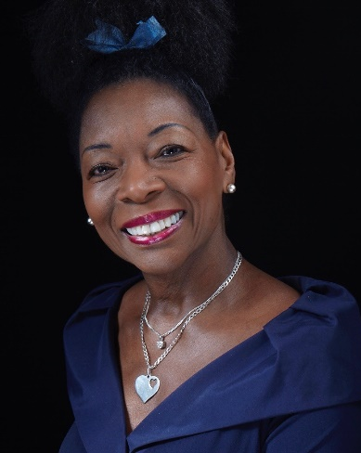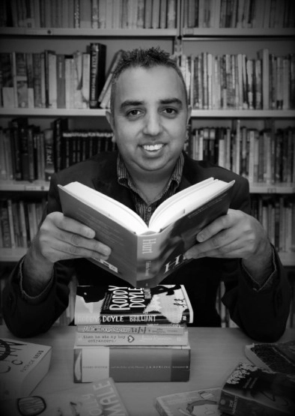

Wednesday 27 March – BookTrust, the UK’s largest children’s reading charity, today announces the high-profile expert judging panel for ‘The BookTrust Storytime Prize’ its brand-new award to celebrate the best books for sharing with babies and children aged 0-5.
The award, run in partnership with Youth Libraries Group will announce its shortlist of six books on the 27 May 2019 at Hay Festival in a special event hosted by Floella Benjamin, which celebrates the joy of sharing stories. The judges for the BookTrust Storytime Prize shortlist include:
- Baroness Floella Benjamin, OBE, author and TV presenter
- Jake Hope Chair of the Youth Libraries Group
- James Mayhew: Author and illustrator of the best-selling Katie series
- Amy McKay: School Librarian of the Year in 2016 and a respected children’s book judge
- Alison Brumwell: Librarian with over twenty years and literacy consultant
- Joy Court: Reviews Editor for The School Librarian journal and Chair of the CILIP Carnegie and Kate Greenaway Medals.
- Julia Hale: Local authority librarian for over twenty years
Jake Hope commented on his involvement in the new prize:
'Some of my earliest and fondest memories are attending the storytime sessions in libraries with my mum. As the Chair of the Youth Libraries Group, I now well know just how important sharing stories with young children is as it contributes massively to early learning, to bonding and to the development of safe attachment, all of this and it is such good fun for all involved. It's a true delight to be working with BookTrust on the new Storytime award which recognises every aspect of this and gives the young readers and families such a positive and pleasurable experience of books, reading and libraries.'

James Mayhew also expressed his excitement for the award:
"This important new prize is a wonderful opportunity to celebrate the very best in imaginative, exciting and diverse books, with outstanding illustrations, that all kinds of families will enjoy. With reading for pleasure at its core, this is something I am very proud to support and which means a great deal to me. I'll be looking for something very special, that I believe every child should experience."
Baroness Floella Benjamin explained:

"Books are such an important part of our children’s well-being as it stimulates their imaginations. I always encourage children to read so that it becomes a lifelong habit. I always give books to babies as presents in the hope that they start a love affair with reading. That’s why I’m excited about this new prize to find the best book for sharing with very young children."

Diana Gerald, BookTrust CEO commented

“We are so incredibly fortunate to have such a passionate and invested judging panel for our inaugural BookTrust Storytime Prize. We are really excited to celebrate the authors and illustrators who inspire little ones to love reading and create stories which last a lifetime.”

Judges will be looking for books which have a wide appeal to parents, carers and young children across our diverse nation, and for accessible and inclusive stories which can be read and enjoyed over and over again.

Over the 2019 summer holidays, the six shortlisted books will be shared with children, carers and families by public librarians from each of the nine English regions (organised in partnership with the Youth Library Group), along with Wales and Northern Ireland, to find the best book for sharing.

The winning book will be announced at a special ceremony in London in November 2019, with a prize of £5000

[Ends]
Press Contacts: Emily Grigg, Press Officer, BookTrust, emily.grigg@booktrust.org.uk, +44 (0)20 7801 8848
Notes to Editors
BookTrust is dedicated to getting children reading because we know that children who read are happier, healthier, more empathetic and more creative. Their early language development is supported and they also do better at school.
We are the UK’s largest children’s reading charity; each year we reach 3.4 million children across the UK with books, resources and support to help develop a love of reading, because we know that reading can transform lives.
We work with a variety of partners to get children excited about books, rhymes and stories, because if reading is fun, children will want to do it. Our books are delivered via health, library, schools and early years practitioners, and are supported with guidance, advice and resources to encourage the reading habit. booktrust.org.uk
Biographies
- Baroness Floella Benjamin, Obe Dl: Actress, author, television presenter, singer, businesswoman and politician. She is known as presenter of children's programmes such as Play School, Play Away and Fast Forward.
- Amy McKay: School Librarian of the Year in 2016, makes regular appearances at Edinburgh and has judged the CILIP Carnegie and Kate Greenaway medals, the Blue Peter Book Awards and the Nibbies.
- Alison Brumwell: With nearly 20 years’ experience as a librarian Alison has held a variety of posts related to children’s and young people’s services, including Bookstart/Early Years Co-ordinator, and is 2019 Chair of the CILIP Carnegie and Kate Greenaway Medal judging panel.
- Jake Hope: Reading development/children's book consultant and has chaired numerous book awards including the prestigious CILIP Carnegie, Kate Greenaway Medals and more.
- Joy Court: Reviews Editor for The School Librarian journal and Chair of the CILIP Carnegie and Kate Greenaway Medals.
- James Mayhew: Author of the best-selling Katie series, to Ella Bella Ballerina, Gaspard the Fox and now Mrs Noah’s Pockets.
- Julia Hale’s: I have been a librarian in local authorities for twenty years (about the same time as the Bookstart programme!) in Westminster, Dorset and Plymouth. I have worked in many roles from Surestart Outreach Officer to Young People’s Services Manager and I am currently Advisor for the Schools Library Service. Part of my role involves training public library staff for sharing books with babies and under fives at rhymetimes and storytimes, so I am always seeking out those books that are not only gorgeously illustrated and well produced but work brilliantly when read out loud.

