Over a million children to be gifted with free books
BookTrust reveals new Bookstart Baby and Treasure packs titles
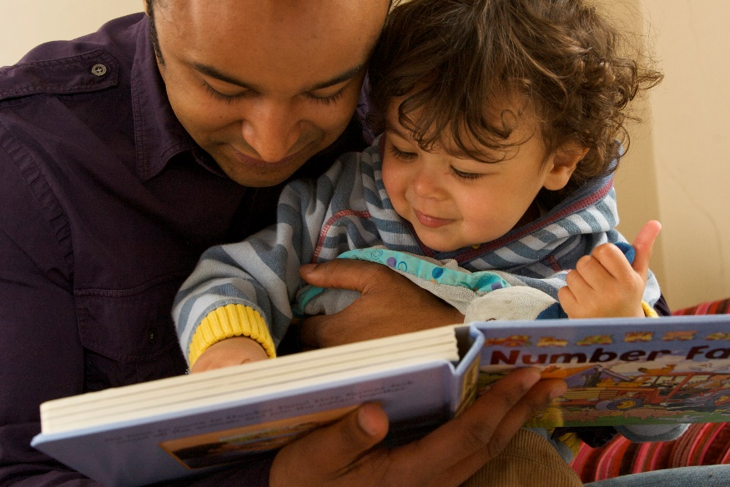
10th January 2018 – BookTrust, the UK’s largest children’s reading charity today reveals the two titles for this years Bookstart Baby and Bookstart Treasure packs.
David Melling’s adorable 123 Splosh and DK’s inclusive All About Me! have been chosen for the Bookstart Baby pack, whilst the bold and colourful Max the Brave by Ed Vere has been selected for the Bookstart Treasure pack.
As part of the Bookstart Baby pack, 600,000 free copies are going to families with babies aged 0-12, who will get their very own 123 Splosh book (published by Hodder) to keep. The colourful rhyming story is a wonderfully funny introduction to numbers and counting for the very young and great to read aloud. The pack also includes rhyme sheets and a booklet filled with tips and ideas for sharing books and stories.
BookTrust has also ordered over 600,000 copies of DK’s All About Me! for their Bookstart Baby packs. This is a wonderfully diverse and inclusive title: two important factors for book selection as the Bookstart packs go to every child in England, regardless of their background. Its fun rhyming text also encourages action and relates to key stages in a child’s development.
Both Bookstart packs are gifted by BookTrust though local councils via a network of health visitors and other professionals and are being sent out from this week to over 1.2 million young children and their families to help get them started on their reading journey.
David Melling, author of 123 Splosh said: “I’m delighted that 123 Splosh has been chosen as the Bookstart Baby read. It’s a wonderful feeling as an author, knowing that over 600,000 families will be given your book to enjoy together. BookTrust do invaluable work, encouraging a love of books at the earliest age, and I’m proud to be part of the programme.”
Meanwhile a further 600,000 free copies of Max the Brave books will go out to children aged 3-4 in their Bookstart Treasure pack which they’ll get from their nursery, children's centre or early years setting. Bookstart Treasure builds on the impact of the Bookstart Baby programme and supports children and families to experience reading and its benefits at a young age. Max the Brave (published by Penguin Random House Children’s UK) is a colourful tale of a brave

kitten who sets out to find a mouse to chase. Vivid, bright and bold, EYFS readers will thoroughly enjoy the story.
Ed Vere, author and illustrator of Max the Brave said: “It’s an incredible honour for my book to be chosen for BookTrust Treasure from such a high-level field of so many amazing books. I can’t tell you how thrilled and delighted I am that so many children are going to get the opportunity to read Max the Brave!
I think it’s so important to put high quality, entertaining and fun books in front of not only children but the grownups who are going to read the books to them. If a grownup is bored reading to a child, that will transmit to the child and if parents know there are great books out there that are entertaining then children will grow up loving reading because it’s fun. I think that’s essential and it’s what reading is all about. Introducing books to children at an early age like this is exactly what we have to do. If we’re going to encourage children to read, which we must because it’s so important, then we have to do it with good books and I’m thrilled that Max is considered a good book. Thank you BookTrust.”
Bookstart, which celebrated its 25th year in 2017 is the world’s first national bookgifting programme, gifting children in England free books at two key ages before they start school, to help develop a love of stories and books.
Diana Gerald, CEO, BookTrust said: “Starting a reading routine early sets young children up to continue reading and enjoying stories as they grow, to find new adventures to get lost in, to experience the simple joy that a story brings. Children who read for pleasure, or are read to from a young age are likely to do better at school, as well as being more socially, culturally and emotionally prepared for life.”
To find out more about each of the books and their authors, visit booktrust.org.uk where Ed is reading Max the Brave and giving away an original illustration and later this month David will also showcase his illustration techniques and giving some advice and tips for budding young artists.
[Ends]
Press Contacts: Sinéad Gosai, Press Officer, BookTrust, sinead.gosai@booktrust.org.uk, +44 (0)20 7801 8849
Notes to Editors
Andrea MacDonald, Editorial Director at Penguin Random House Children’s said: “How wonderful to support BookTrust in their amazing work; we’re thrilled that Ed’s gorgeous, funny, and empowering book, Max the Brave is going to be shared with so many pre-schoolers across England. It’s a delight to read and reread, and is a brilliant start on the path to a love of words and pictures.”
Emma Layfield, Picture Book Publisher, Hodder Children’s Books said: “‘We know how incredibly important it is for families to begin enjoying books together at the earliest possible age, and 123 Splosh is the perfect read to begin that journey. We’re so pleased and proud to be working with BookTrust and to support this year’s Bookstart Baby.”
Ed Vere is the author and illustrator of numerous picture books. Max the Brave is a New York Times and USA Today bestseller and its sequels Max at Night and Max and Bird. He lives in London, England. Learn more about Ed’s work at edvere.com.

David Melling has been shortlisted for the Kate Greenaway Medal, the Smarties Book Award and the Independent Booksellers Award. His Hugless Douglas books have sold over 1.5 million copies worldwide, and the loveable brown bear has starred in a World Book Day book as well as his own theatre show. Hello, Hugless Douglas was a number one bestseller across all charts. He visits schools both in the UK and internationally, inspiring children to love reading, and he’s a regular at high profile literary festivals. Before becoming an internationally-acclaimed author-illustrator, David worked as an animation artist for films including the much-loved Father Christmas by Raymond Briggs. One of his most popular picture books The Tale of Jack Frost was animated and shown on BBC1 on Christmas Day.
BookTrust is the UK’s largest children’s reading charity. We work to inspire a love of reading in children because we know that reading can transform lives. Each year we reach 3.4 million children across the UK with books, resources and support to help develop a love of reading. Every parent receives a BookTrust book in their baby’s first year. Our books are delivered via health, library, schools and early year’s practitioners, and are supported with guidance, advice and resources to encourage the reading habit. Reading for pleasure has a dramatic impact on educational outcomes, well-being and social mobility, and is also a huge pleasure in itself. We are committed to starting children on their reading journey and supporting them throughout. booktrust.org.uk
Hachette Children's Group is one of the largest children's publishers in the UK, with an excellent track record in creating bestselling and award-winning books for children of all ages and interests.
The Group comprises the imprints Hodder Children’s Books, Orchard Children’s Books, Orion Children’s Books, Little, Brown Books for Young Readers, Quercus Children’s Books, Pat-a-Cake, Wren & Rook, Franklin Watts and Wayland Books. The Group is also the publisher of author Enid Blyton and the owner of Enid Blyton Entertainment.
Across its imprints, Hachette Children’s Group’s publishes a diverse range of books to cater for every child, including picture books, fiction, non-fiction and series and licensed publishing. Their authors, illustrators, series and licenses include: David Almond, Lauren Child, Cressida Cowell, Kes Gray, Jim Field, Nadiya Hussain, Patrice Lawrence, Michael Rosen, Francesca Simon, Alex T. Smith, Lauren St. John, Piers Torday, Rainbow Magic, My Little Pony and Pokémon. hachettechildrens.co.uk | @hachettekids
Penguin Random House is the world’s number one publisher. We champion authors, shaping and sharing writing that sparks thoughts, dreams, conversations and learning.

We a vibrant community of publishing houses, representing distinguished publishing histories marked by unparalleled success. We are a home to all kinds of authors. From the best new fiction or picture book writers, to political commentators, trailblazing entrepreneurs, health experts and bold illustrators, we enable talented people from all walks of life to tell their stories – and we make sure they are heard. We sell and license books in over 120 countries, connecting great books with a growing and global audience.

We bring words to life.
https://www.penguinrandomhouse.co.uk/
https://www.penguin.co.uk/

