‘Every child should have access to literature and creativity,’ say two Children’s Laureates
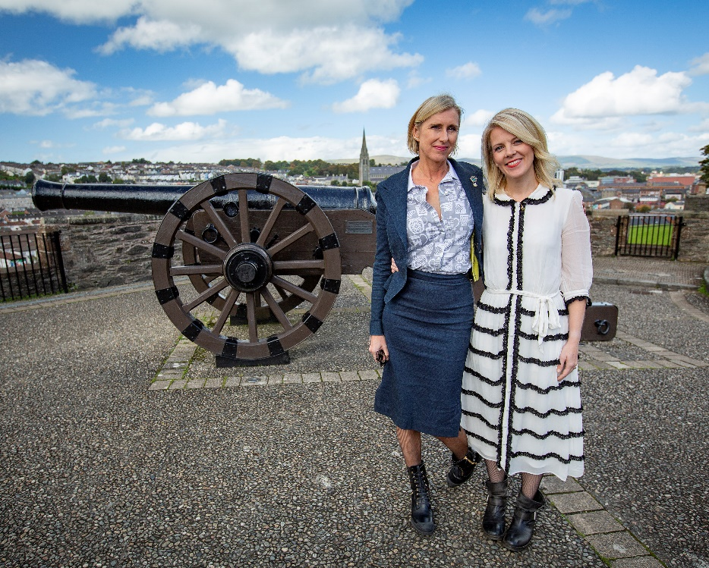
Lauren Child with Sarah Crossan at Verbal, Derry
Waterstones Children’s Laureate Lauren Child meets with Laureate na nÓg Sarah Crossan at BookTrust NI event in Derry
On Saturday 22 September 2018 at Verbal Derry UK Waterstones Children’s Laureate Lauren Child was joined by Laureate na nÓg Sarah Crossan to discuss their Laureate roles, books and creativity with Julia Eccleshare.
Laureate na nÓg Sarah Crossan said: “It feels appropriate given my strong family ties to Donegal and Derry that my first public event as Laureate na nÓg should be here at the Verbal. Northern Ireland is in a fortunate and unique position: it has two children's laureates. This is a great opportunity for myself and the UK Laureate Lauren Child to share not just a stage, but our joint conviction that every child should have access to literature and to creativity. During my two-year term I want to empower young people across the island of Ireland to express themselves through poetry, to show them that words are powerful - and they belong to all of us. #WeAreThePoets.”
Waterstones Children’s Laureate Lauren Child said :“I am so happy to be returning to Northern Ireland. It’s been a long time since I was last here, but I have such good memories of my last visit and now many more from this new visit.”
Writer, broadcaster and lecturer Julia Ecleshare chaired the discussion between the two Children’s Laureates where they spoke about the importance of illustrations in books and the ability they have to encourage readers to decipher meaning for themselves. They also spoke about children’s books helping children to understand the world around them, often providing solace from the darkness they may be facing.
Liz Canning, Head of BookTrust Northern Ireland, said: “We are delighted Lauren Child made a special visit to Northern Ireland as The Waterstones Children’s Laureate and met with Laureate na nÓg Sarah Crossan. We hope this BookTrust hosted event helped inspire families and practitioners in Derry to get reading and get creative!”
The event took place at Verbal, Derry and was hosted by BookTrust NI who is supported through the Arts Council of Northern Ireland's National Lottery funds.
Damian Smyth, Head of Literature and Drama at the Arts Council of Northern Ireland: “Working closely with Booktrust in Northern Ireland means that the Arts Council can help with events such as this one – a unique opportunity to experience Lauren Child, the Waterstone’s UK Children’s Laureate, in conversation with Laureate na nÓg Sarah Crossan. It’s a message we are delighted to endorse for all children and young people in the company of such excellent practitioners.”
James Kerr, Chief Executive of Verbal said: “We are especially delighted to welcome our Children’s Laureates Lauren and Sarah to Verbal today to share their brilliant stories and to encourage others and especially our young people to do the same. Through the transformational power of storytelling people can come together to create a better, fairer and more equal society.”
ENDS
Press contact: Bethan Phillips, Press Officer BookTrust, bethan.phillips@booktrust.org.uk 020 7801 8848
BookTrust is the UK’s largest children’s reading charity. We work to inspire a love of reading in children because we know that reading can transform lives. Each year we reach 3.4 million children across the UK with books, resources and support to help develop a love of reading, because we know that reading can transform lives. Our books are delivered via health, library, schools and early year’s practitioners, and are supported with guidance, advice and resources to encourage the reading habit. Reading for pleasure has a dramatic impact on educational outcomes, well-being and social mobility, and is also a huge pleasure in itself. We are committed to starting children on their reading journey and supporting them throughout. www.booktrust.org.uk
About the Waterstones Children’s Laureate
The idea for the Children’s Laureate originated from a conversation between (the then) Poet Laureate Ted Hughes and children’s writer Michael Morpurgo. The role of Waterstones Children's Laureate, which has a bursary of £15,000, is awarded once every two years to an eminent writer or illustrator of children's books to celebrate outstanding achievement in their field. The appointment of a Waterstones Children's Laureate acknowledges the importance of exceptional children's authors in creating the readers of tomorrow. The role of Laureate covers the whole of the UK and is administered by BookTrust, the children’s reading charity, and sponsored by Waterstones. It would be appreciated if you could ensure your editorial is factually accurate by referring to the role in its full title, Waterstones Children’s Laureate, at least once. For more information please visit www.childrenslaureate.org.uk.

