BookTrust partners with ClearVision Project to bring Braille books to children
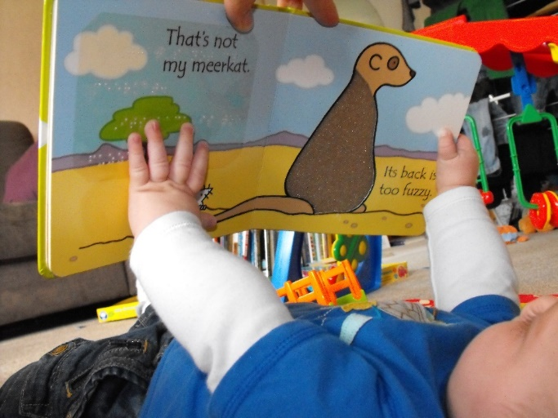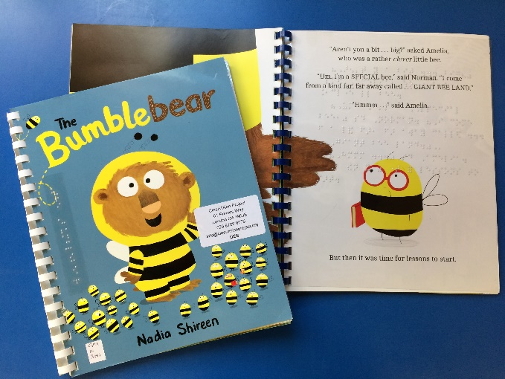

12th November - Today BookTrust, the UK’s largest children’s reading charity, announces its partnership with the ClearVision Project to help support reading for blind and partially sighted children.

ClearVision runs a postal lending library of children's books which have been adapted to include the text in braille on clear plastic pages, so that sighted and braille-reading families can share stories.

BookTrust and ClearVision have adapted twenty new copies of BookTrust’s special 2017 Time to Read book, The Bumblebear (published by Puffin) written and illustrated by Nadia Shireen, to make it more accessible to braille readers. The specially adapted books are now in the ClearVision library ready for families to borrow. Joining the ClearVision library opens up a wealth of shared reading, and braille-reading children get not one but four free books to keep through their My Home Library scheme! Schools are also welcome to join for shared reading in the classroom.

Alexandra Britton, Director, ClearVision Project said: “We’re delighted to be working with Booktrust on this brilliant project. Shared reading is important for all children, and for children learning to read braille, it’s vital. Research makes clear that being able to read braille opens up greater opportunities in education and employment, but children need every possible support to learn and every opportunity to practice. These books will help more families read together, helping kids learn but importantly also enjoying the pleasure of sharing a great story.”

Diana Gerald, CEO, BookTrust said: “Getting books in the hands of all children is so incredibly important. BookTrust’s mission is to inspire every child to love books and become lifelong readers, but without the correct tools, visually impaired children will struggle more than they really need to.
We’ve teamed up with the ClearVision Project to make sure children with little or no sight can enjoy adventures within the pages, enjoy books and share stories.”

Nadia Shireen, author of The Bumblebear said: “I’m so chuffed that BookTrust and Clearvision have worked to together to create Braille copies of Bumblebear. Every author wants their stories to be shared by as many people as possible, so I’m really happy that more kids get to enjoy Norman’s furry misadventure.”
ClearVision currently has over 300 schools and services taking part and enjoying the benefits of shared reading. Visit www.clearvisionproject.org to join the lending library.
[Ends]
Press Contacts:
Sinéad Gosai, BookTrust, sinead.gosai@booktrust.org.uk, +44 (0)20 7801 8849 or Alexandra Britton, The ClearVision Project, info@clearvisionproject.org, +44 (0)20 8789 9575

The ClearVision Project runs a postal lending library of children's books which have been adapted to include the text in braille on clear plastic pages, so that print, braille and pictures are all together on the page. This makes them perfect for braille readers and print readers to share. Children who are learning braille can get crucial support from sighted parents and teachers; braille reading parents and grandparents can read with their sighted children. Everyone can enjoy a bedtime story together- one of the great pleasures of childhood.
The library is free for families to join, and books are sent using the Articles for the Blind freepost. The collection runs from board books for babies up to short chapter books for readers who are nearly reading independently and includes everything from favourite friends like the Gruffalo and Horrid Henry to best-selling authors like Jacqueline Wilson, Michael Morpurgo and Roald Dahl. The scheme is also great for paired reading or projects in the classroom, and over ___ schools, nurseries and Sensory Support Services across the UK and Ireland are members. For more information, or to sponsor a book, see www.clearvisionproject.org

BookTrust is dedicated to getting children reading because we know that children who read are happier, healthier, more empathetic and more creative. Their early language development is supported, and they also do better at school.
We are the UK’s largest children’s reading charity; each year we reach 3.4 million children across the UK with books, resources and support to help develop a love of reading, because we know that reading can transform lives.
We work with a variety of partners to get children excited about books, rhymes and stories, because if reading is fun, children will want to do it. Our books are delivered via health, library,
schools and early years practitioners, and are supported with guidance, advice and resources to encourage the reading habit. booktrust.org.uk

