Chris Riddell joins BookTrust
Former Waterstones Children’s Laureate becomes an Ambassador at UK’s largest children’s reading charity

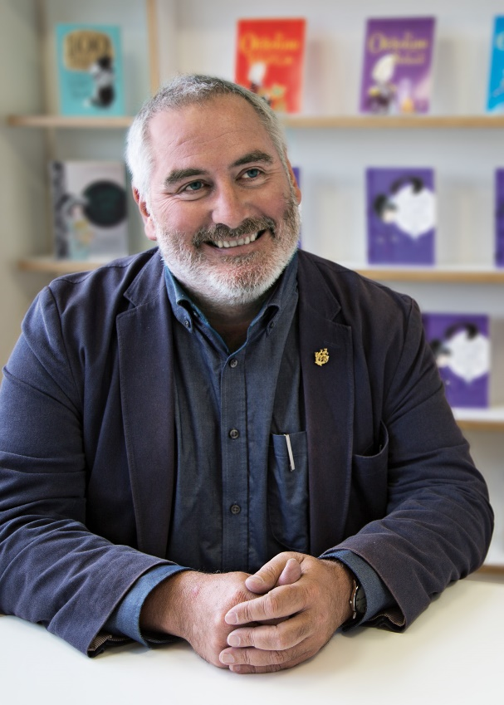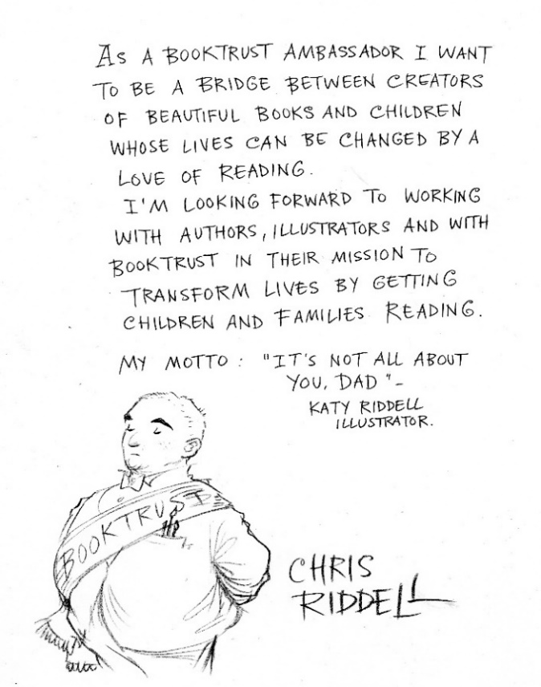

26 September 2017 – BookTrust, the UK’s largest children’s reading charity today announces that Chris Riddell, author/illustrator and former Waterstones Children’s Laureate is joining the charity as an ambassador.
Chris, also a political cartoonist for The Observer, will continue championing the value and immense benefits of reading for pleasure and encouraging children to get lost in the world of books.
Each ambassadorship will last five years. During his term at BookTrust, Chris will attend a variety of events, visit cared for children who are part of the Letterbox programme, take part in much loved library Rhyme Time sessions, as well as providing written content and illustrations to encourage more families to read together.
Riddell will continue his work as an author and illustrator and remain a dedicated advocate for libraries, which he vehemently supports. Talking about the importance of reading he says: “Books are like doors, you can open them and step into another place...or time...or world.”
Goth Girl and the Sinister Symphony (Pan Macmillan) is Chris’s latest book and yet another imaginative addition to the multi-award-winning Goth Girl series. It is a hilarious twist on a well-known classic novel, with unforgettable characters, pun-filled plot and his infinitely recognisable illustrations.
Discussing his new ambassador role at BookTrust, Chris said: "I'm in a perfect place to become BookTrust's ambassador after my two years as Children's Laureate. I want to be a bridge between creators of beautiful books and children whose lives can be changed by a love of reading. I'm looking forward to working with authors, illustrators and with BookTrust in their mission to transform lives by getting children and families reading.”
Diana Gerald, CEO, BookTrust said: “We’re delighted to welcome Chris to BookTrust. His books and illustrations are loved by children of all ages. We are so looking forward to working with him because of his commitment, passion and incredible energy to do whatever it takes to help us achieve our mission to get all children reading. Thank you Chris for coming on board, we are so excited about what we can achieve together.”
[Ends]
For interview requests please contact: Sinéad Gosai, sinead.gosai@booktrust.org.uk, +44 (0)20 7801 8849
Chris Riddell, the 2015-2017 UK Children's Laureate, is an accomplished artist and the political cartoonist for the Observer. He has enjoyed great acclaim for his books for children. His books have won a number of major prizes, including the 2001, 2004 and 2016 CILIP Kate Greenaway Medals. Goth Girl and the Ghost of a Mouse won the Costa Children's Book Award 2013. His previous work for Macmillan includes the bestselling Ottoline books, The Emperor of Absurdia, and, with Paul Stewart, the Edge Chronicles, the Muddle Earth books, the Scavenger series and the Blobheads series. Chris lives in Brighton with his family.
BookTrust is the UK’s largest children’s reading charity. We work to inspire a love of reading in children because we know that reading can transform lives. Each year we reach 3.4 million children across the UK with books, resources and support to help develop a love of reading. Every parent receives a BookTrust book in their baby’s first year. Our books are delivered via health, library, schools and early year’s practitioners, and are supported with guidance, advice and resources to encourage the reading habit. Reading for pleasure has a dramatic impact on educational outcomes, well-being and social mobility, and is also a huge pleasure in itself. We are committed to starting children on their reading journey and supporting them throughout. booktrust.org.uk

