BookTrust teams up with LEGO to develop children’s creativity and imagination
50,000 families in South England gifted with free books and LEGO

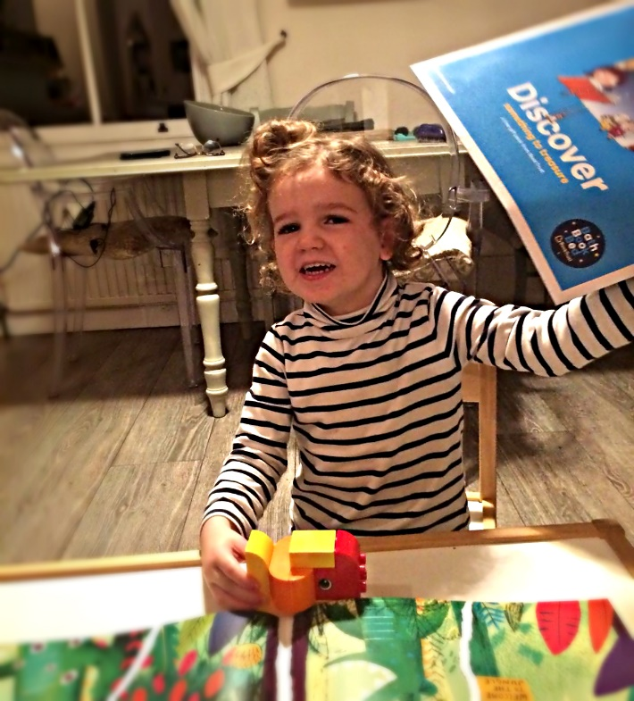
23nd November- Toy manufacturer LEGO has teamed up with BookTrust, the UK’s largest children’s reading charity, to encourage imagination, creativity and help early child development. The partnership sees LEGO provide BookTrust with 50,000 packs of their DUPLO product to be given out alongside Bookstart Treasure.
Bookstart Treasure is BookTrust’s book gifting programme aimed at families with children aged 3-4 years. Each year 680,000 packs are distributed to children through local libraries, nurseries and children’s centres. The packs are filled with engaging books and resources to support families encourage a love of reading in children from an early age. Treasure is part of BookTrust’s flagship programme Bookstart, which celebrates its 25th anniversary this year.
The LEGO DUPLO product is aimed at children aged 2-4 years old and the packs will contain building blocks used to create animal figures. The dual packs are being distributed between September to November 2017 to a limited number of families in the South England as part of a pilot project.
Diana Gerald, BookTrust CEO said:
“There are many benefits of reading for pleasure including the development of children’s creativity and imagination, which is why we are delighted to help support this by offering families an additional resource in their Treasure packs. LEGO does fantastic work helping children play and learn new skills. We hope those families receiving their special DUPLO product with their Treasure pack enjoy watching their child having fun and getting creative!”
Aliya Beissova, Senior Brand Manager at Lego said:
“LEGO is thrilled to be working with the UK's largest children's reading charity, BookTrust, to deliver our DUPLO play experience to over 50,000 pre-school children. It was a natural partnership and we recognise this initial trial activity as mutually beneficial for both organisations due to our common goals which include aiding early childhood development, inspiring creativity and stimulating little imaginations.”
Emma Fisher, Children and Young People’s Librarian, South Gloucestershire Libraries said:
“Working with pre-school teachers they were very impressed and thought how well the LEGO DUPLO went with the story ‘Alan’s Big Scary Teeth’. We are planning on doing an activity with the children during their class visit to the library next week using the story and LEGO to explore different feelings.”
Parent of Luke, Kennington, said:
“My son loves books and will add to his collection. We do bath, book, bed every night and this is what we did with the new book. Luke built a fish from the Duplo which joined him in the bath.”
ENDS
Press Contacts: Bethan Phillips, Press Officer, BookTrust, Bethan.phillips@booktrust.org.uk, 020 7801 8848

Notes to Editors
BookTrust is the UK’s largest children’s reading charity. We work to inspire a love of reading in children because we know that reading can transform lives. Each year we reach 3.4 million children across the UK with books, resources and support to help develop a love of reading. Every parent receives a BookTrust book in their baby’s first year. Our books are delivered via health, library, schools and early year’s practitioners, and are supported with guidance, advice and resources to encourage the reading habit. Reading for pleasure has a dramatic impact on educational outcomes, well-being and social mobility, and is also a huge pleasure in itself. We are committed to starting children on their reading journey and supporting them throughout. booktrust.org.uk

About the LEGO® Group
The LEGO® Group is a privately held, family-owned company with headquarters in Billund, Denmark, and main offices in Enfield, USA, London, UK., Shanghai, China, and Singapore. Founded in 1932 by Ole Kirk Kristiansen, and based on the iconic LEGO® brick, it is one of the world's leading manufacturers of play materials.
Guided by the company spirit: "Only the best is good enough”, the company is committed to the development of children and aims to inspire and develop the builders of tomorrow through creative play and learning. LEGO products are sold worldwide and can be virtually explored at www.LEGO.com.
For more news from the LEGO® Group, information about our financial performance and responsibility engagement, please visit http://www.LEGO.com/aboutus.
LEGO®, the LEGO® logo, the Minifigure, the brick and knob configuration are trademarks of the LEGO® Group. © 2016 the LEGO® Group.

