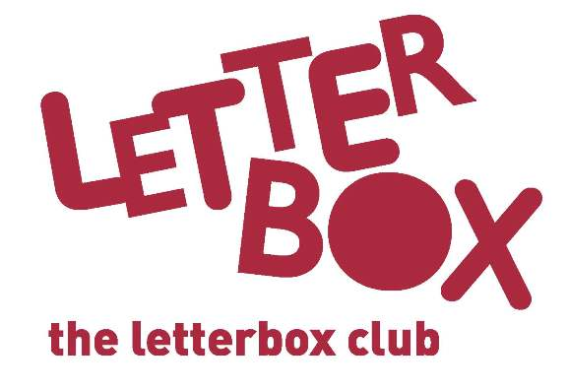
Parent name
Address 1
Address 2
Address 3
Postcode

Date

Welcome to The Letterbox Club!

Dear Parent,

[Insert school] is taking part in The Letterbox Club, a programme which aims to inspire a love of reading and engagement with numeracy in children aged 3-13. It’s run by a reading charity called BookTrust, in partnership with the University of Leicester.
We’re excited to let you know that your child will receive a brightly coloured parcel, once each month for six months. The parcels are theirs to own and keep, and contents include:

- A range of carefully selected books from different genres.
- Fun number games that can be played individually or as a group – you might want to join in the fun!
- Stationery items, for writing and drawing, and other supportive materials.
- Some of the parcels also include letters from famous children’s authors.

Please let your child know about the Letterbox Club, we hope they’ll be excited to receive their first parcel!

If you have any questions, please get in touch with [Insert school contact]. You can also find out more about Letterbox Club by visiting booktrust.org.uk/letterbox-club-families

We may also get in touch with you to ask for your feedback about the programme.

Best wishes,
The Letterbox Club

Turn over for some top Letterbox tips...

Top Tips

- Remember, the Letterbox Club isn’t homework and your child can use the parcels at their own pace.
- Having special time together to read, talk and look at the parcels is important. Taking some time each day to share a story or talk about books can make a huge difference!
- We hope you have fun too…You might want to do some drawing together or talk about which stories you enjoyed the most.
- You may find that your child only likes some of the books in some of the parcels, that’s fine! If they want to look at one book over and over again, that’s fine too.

We hope you and your child enjoy being part of the Letterbox Club!

