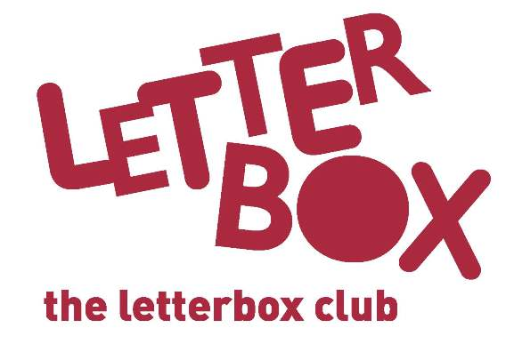
Headteacher name
Address 1
Address 2
Address 3
Postcode

Date

The Letterbox Club

Dear Headteacher,

[Insert local authority] is taking part in The Letterbox Club, a programme which aims to inspire a love of reading and engagement with numeracy in children who are looked-after and other vulnerable children aged 3-13. It’s run by a reading charity called BookTrust, in partnership with the University of Leicester.
Across the UK, children are enrolled for the Letterbox Club by local authorities and schools. Each participating child receives their own colourful parcel of books, number games, stationery and other supportive materials once every month for six months, all aimed at stimulating reading in the home. If the child moves during this time, parcels will be sent to their new address until the end of the programme.

We wanted to let you know about the programme, as some children in your school are taking part. You might also want to share this information with your Designated Teacher.

If you want to know more about the Letterbox Club, so you can talk to the children about their parcels, please get in touch at Letterbox@booktrust.org.uk.

As part of programme evaluation, our local authority might get in touch with you about a particular child.

Best wishes,

[Insert contact/ LACE coordinator]

- For more information about the Letterbox Club, please visit: www.booktrust.org.uk/letterbox-club
- If you’d like to get in touch about children taking part, please contact: [Insert local contact details]

