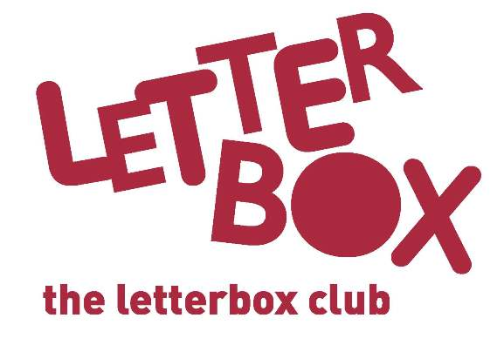
Carer/Parent name
Address 1
Address 2
Address 3
Postcode

Date

Welcome to The Letterbox Club!
Dear Carer,

[Insert local authority/school] is taking part in The Letterbox Club, a programme which aims to inspire a love of reading and engagement with numeracy in children who are looked-after aged 3-13. It’s run by a reading charity called BookTrust, in partnership with the University of Leicester.
We’re excited to let you know that your child will receive a brightly coloured parcel, once each month for six months. The parcels are theirs to own and keep, and contents include:

- A range of carefully selected books from different genres.
- Fun number games that can be played individually or as a group – you might want to join in the fun!
- Stationery items, for writing and drawing, and other supportive materials.
- Some of the parcels also include letters from famous children’s authors!

Please let your child know about the Letterbox Club, we hope they’ll be excited to receive their first parcel! If your child moves during this time, we’ll make sure the parcels are sent to their new address.

You’ll find information and practical tips about reading with your child by visiting https://www.booktrust.org.uk/tips-for-carers-and-foster-families

If you have any questions, or you move address, please get in touch with [Insert local contact/ your LACE coordinator]. You can also find out more about Letterbox Club by visiting booktrust.org.uk/letterbox-club-families

We may also get in touch with you to ask for your feedback about the programme.
Best wishes,
The Letterbox Club
Turn over for some top Letterbox tips…
Top Tips

- Remember, the Letterbox Club isn’t homework; there’s absolutely nothing your child has to do, and they can use the parcels at their own pace.
- Having special time together to read, talk and look at the parcels is important. Taking some time each day to share a story or talk about books can make a huge difference.
- We hope you have fun too. You might want to do some drawing together or talk about which stories you enjoyed the most.
- You may find that your child only likes some of the books in some of the parcels, that’s fine! If they want to look at one book over and over again, that’s fine too.

We hope you and your child enjoy being part of the Letterbox Club!

