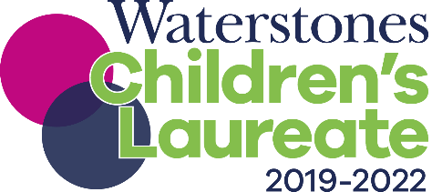
Dear Readers,

The book is the ultimate survivor: it has emerged, sometimes torn but always victorious, through wars, upheaval, suppression, and yes, plagues. It has lived with the advent of television, video games and the internet. It has survived, quite simply, because we need it.
I was asked last week by the World Health Organisation and UNICEF to deliver a message not only about staying home and washing our hands but also about reading books, because we know from much research how valuable they are for mental health.
Books are our tool to make sense of the inexplicable, to articulate to ourselves what we feel but cannot always say. They’re our comfort, our distraction, a way to travel when life seems dark and is closing in on us, a way to laugh when not much seems funny. They’re an anchor to a reassuring past in the face of a worrying present and an uncertain future. They connect us both with strangers and, if we read aloud and enjoy them together with the ones we love the most.
When a child needs to grasp for courage, they can find it with the help of characters like Matilda, or Hiccup the Viking. I can find it with Atticus Finch. Real courage, according to Atticus, is: ‘when you know you're licked before you begin but you begin anyway and you see it through no matter what. You rarely win, but sometimes you do.’ The ‘sometimes you do’, is important. I’m always aiming for the ‘sometimes you do.’
We’ve been forced inwards, but so many people are using books to reach out. Grandparents, teachers and librarians are doing virtual story times, bookshops are delivering books with soup, publishers are opening up permissions and giving free ebooks to NHS workers, festivals are going online. Authors and illustrators are sharing their work by reading aloud, or drawing, or encouraging others to be creative, and new hubs like BookTrust HomeTime are collating some of the wonderful material. Book-y people have tenacity and resourcefulness because we are passionate about what we do.
I have faith in the resilience of books, and the book trade, and in our children, too. Writing for children is the greatest privilege on earth, for what a gift it is, to look at the world through the cool, clear eyes of a child. Where adults can be distracted by trivialities, children seem to have a wondrous ability to know what are the essentials: heroism, wilderness, our relationship with the natural world, death, love, spirituality, adventure… and optimism. At the end of my street, like so many other streets across the UK, some children have reacted to the anxious voices on the radio and the TV by drawing the most gigantic chalk rainbow on their wall. They made that rainbow as stupendous and as chaotic and as colourful as they possibly could. If they could have found a bigger wall, I firmly believe they would have made it even larger.
The adults have a lot to learn from children’s instinctive hopefulness, and their joyfully unrealistic ambition for the future. Because their belief in the impossible just might make it happen.
Less than a year ago, I spoke at the Globe about the urgent necessity of making sure every single child in this country has access to books. This is a challenging time, and it is when times are hardest that we need the transformative magic of books and reading the most. To bring books into the hands of each and every child in the UK is going to require practical magic, action, and the kind of hope and imagination and creativity which children specialise in.
Because reading is magic, and magic is for everyone.
Love,
