UNDER STRICT EMBARGO UNTIL: THURSDAY 11TH OCTOBER 00:01
Without books children are dumped into a cultural wasteland, says Baroness Floella Benjamin at BookTrust Annual Lecture
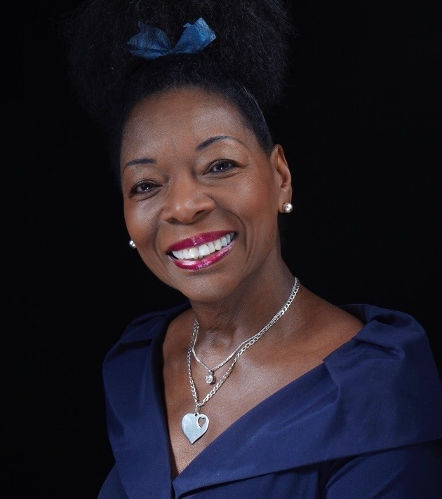
11th October 2018 - Baroness Floella Benjamin OBE, will this evening deliver her thoughts on the vital role that books play in a child’s life, arguing that not owning a book stifles their imagination and should be considered harmful to their cultural development.
Discussing this with an audience of publishing officials, authors, illustrators and key industry figures, Baroness Floella Benjamin will argue that books for children are crucial to providing emotional support and that reading and sharing stories is so much more than nice words and pretty pictures. She strongly believes books can provide stability, structure and foster wellbeing which cannot only inspire young minds, but also help shape their life and direction. The Baroness declares that what happens in your childhood lasts a lifetime and that books and reading can have an ongoing impact. Her experiences, over the last 40 years, working with and for children have helped to re-enforce this.
Baroness Floella Benjamin, who is part of the Windrush Generation, was born in Trinidad and came to England in 1960, aged ten, says that even now, there aren’t enough books yet that represent our multicultural society and that there are still very few children’s writers of colour. All children should be able to see their faces in the illustrations and recognise stories they can identify with. Malorie Blackman’s books are perfect examples of how this can be achieved. Books should speak to children by understanding who they are, with relatable plots, and most importantly the characters should be recognisable and not just perpetuate stereotypes or caricatures. Back in the 80’s when she was Chair of the Smarties Book Prize, iconic figures like Helen Oxenbury and Shirley Hughes, listened to her plea and paved the way for diversity. They opened up the landscape at a time when there was little recognition of non-white characters.
Baroness Benjamin is also calling on authors, illustrators and the publishing industry at large to understand the privileged position they hold when creating books for children. Urging everyone involved to properly understand the enormity of the task and the importance they hold in a reader’s life. It’s not just about making money, it’s about making a difference. Not being flippant and outrageous just for the sake of it.

Baroness Floella Benjamin said: “Legacy matters! When a book is created it can have a lasting impact on a child. We might not know their mental state, their circumstances and what reading the book may mean to them, but it is definitely shaping the blank canvas of a child’s mind.
And yet unbelievably some children have never even owned or read a book. That’s why I passionately believe that denying them access to books is like starving them of creativity, stifling their imagination and dumping them into a cultural wasteland without a compass. This is why the work of BookTrust is so important, they put books in the hands of all children regardless of their background. Books and storytelling can take children to far flung lands, or on exciting adventures, they can offer comfort, a place for their minds to go, or provide a much-needed escape from abusive situations. The magnitude of this impact should not be overlooked or ignored because as I always say, childhood lasts a lifetime.”
The lecture is the third in the series to date, with award winning journalist and broadcaster Samira Ahmed as the master of ceremonies. BookTrust’s inaugural lecture launched Michael Morpurgo’s campaign to reinstate story time in schools. Then in 2017, Lauren Child, the Waterstones Children’s Laureate, called for children's books to be taken seriously and advocated for children being allowed to daydream and let their minds run free.
Diana Gerald, CEO, BookTrust said: “We’re honoured to welcome Baroness Floella Benjamin to the stage. A true titan of industry and a supporter of BookTrust from the early days, her passion and enthusiasm for children’s reading is evident and we’re proud to provide a platform for such important issues to be discussed, to hopefully impact change, right some wrongs and ensure that all children, not only have access to books, but also to allow them to identify characters as like them.”
[Ends]
Press Contacts: Sinéad Gosai, Press Officer, BookTrust, sinead.gosai@booktrust.org.uk, +44 (0)20 7801 8849
Notes to editors
Baroness Floella Benjamin, OBE, DL was born in Trinidad in 1949 and came to England in 1960, aged 10. She is an actress, presenter, writer, producer, working peer and an active advocate for the welfare and education of children. She is best known as a presenter of the iconic BBC children’s television programmes Play School and Play Away, and she continues to make children’s programmes. Her broadcasting work has been recognised with a Special Lifetime Achievement BAFTA and OBE. She was appointed a Baroness in the House of Lords in 2010 where she continually promotes legislation to protect children’s wellbeing. In 2012 she was presented with the prestigious J. M. Barrie Award by Action for Children’s Arts, for her lasting contribution to children’s lives through her art. Floella has written thirty books, including Coming to England, a Guardian Children’s Book of the Year 2016, which is used as a resource in schools in social and cross-curricular areas. The book was adapted into an award-winning film for BBC Education. She was also appointed Chancellor of the University of Exeter until 2016 and this year had honorary Freedom of the City of London bestowed upon her.
BookTrust is dedicated to getting children reading because we know that children who read are happier, healthier, more empathetic and more creative. Their early language development is supported, and they also do better at school.
We are the UK’s largest children’s reading charity; each year we reach 3.4 million children across the UK with books, resources and support to help develop a love of reading, because we know that reading can transform lives.
We work with a variety of partners to get children excited about books, rhymes and stories, because if reading is fun, children will want to do it. Our books are delivered via health, library, schools and early years practitioners, and are supported with guidance, advice and resources to encourage the reading habit. booktrust.org.uk

